EXPERIMENTAL MEDICINE
ЕКСПЕРИМЕНТАЛЬНА МЕДИЦИНА

DOI 10.26724/2079-8334-2022-3-81-201-206
UDC 616.857: [616.831-073.432.19:616.711.1-073.7]

A.I. Gozhenko, R.S. Vastyanov¹, O.G. Rodinsky², V.M. Bibikova², P.P. Yermuraki¹, V.Yu. Ilina-Stohnienko¹ SE “Ukrainian research institute of Transport Medicine of the Ministryof Health of Ukraine”, Odesa, ¹Odesa National Medical University, Odesa, ²Dnipro State Medical University, Dnipro INFLUENCE OF CALCIUM CHANNELS BLOCKADE ON NEUROLOGICAL DISORDERS

EXPRESSION AND MORTALITY RATE OF ANIMALS IN EXPERIMENTAL HEMORRHAGIC STROKE e-mail: rvastyanov@gmail.com

The purpose of the study was to investigate the relationship between the mortality of experimental animals and methods
of neurological status studying, behavioural and cognitive disorders in the dynamics of primary and recurrent hemorrhagic stroke and this pathological state pharmacological correction using calcium channel blockers. Two models of local stroke were used in the studies: the model of acute and repeated hemorrhagic stroke. The article analyzes and compares the mortality rates of experimental animals with the use of various methods of studying primary and recurrent hemorrhagic stroke. We studied and analyzed the dynamics of changes in mortality during the study of neurological status, behavioural and cognitive disorders and performed statistical analysis of animal mortality at different stages of the experiment, which correlated with the severity of neurological disorders and depth, dynamics of primary and recurrent hemorrhagic strokes. It was found that animal mortality depends on the method of hemorrhagic stroke reproduction and its reduction correlates with spontaneous partial recovery of impaired motor function and neurological status in the dynamics and is corrected by medication with calcium channel blockers. Authors demonstrated hemorrhagic stroke-induced animal’s mortality dependence on the pathogenetically based pharmacocorrection. The data received might be considered as an experimental background of reasonability of calcium channels blockers effects testing in clinical conditions at hemorrhagic strokes.
Key words: primary hemorrhagic stroke, recurrent hemorrhagic stroke, mortality, neurological deficit, behavioural
changes, memory disturbances, calcium channel blockade

А.І. Гоженко, Р.С. Вастьянов, O.Г. Родинський, В.M. Бібікова, П.П. Єрмуракі, В.Ю. Ільїна-Стогнієнко ВПЛИВ БЛОКАДИ КАЛЬЦІЄВИХ КАНАЛІВ НА ВИРАЖЕНІСТЬ НЕВРОЛОГІЧНИХ ПОРУШЕНЬ ТА ПОКАЗНИКИ ЛЕТАЛЬНОСТІ ТВАРИН ПРИ ЕКСПЕРИМЕНТАЛЬНОМУ ГЕМОРАГІЧНОМУ ІНСУЛЬТІ

Мета дослідження – дослідити взаємозв’язок між смертністю піддослідних тварин та методами дослідження неврологічного статусу, поведінкових та когнітивних розладів у динаміці первинного та повторного геморагічного інсульту та фармакологічної корекції цього патологічного стану за допомогою блокаторів кальцієвих каналів. У дослідженнях застосовували дві моделі локального інсульту: модель гострого та повторного геморагічного інсульту. У статті проаналізовано та порівняно показники смертності експериментальних тварин із застосуванням різних методів дослідження первинного та повторного геморагічного інсульту. Вивчено та проаналізовано динаміку змін смертності під час дослідження неврологічного статусу, поведінкових та когнітивних розладів та проведено статистичний аналіз смертності тварин на різних етапах експерименту, що корелює з тяжкістю та глибиною неврологічних розладів, динамікою первинного та повторного геморагічного інсульту. Встановлено, що смертність тварин залежить від способу відтворення геморагічного інсульту та її зниження корелює зі спонтанним частковим відновленням порушень рухової функції та неврологічного статусу в динаміці та коригується введенням блокаторів кальцієвих каналів. Автори продемонстрували залежність смертності тварин при геморагічному інсульті від патогенетично обґрунтованої фармакокорекції. Отримані дані можна розглядати як експериментальне обґрунтування доцільності перевірки дії блокаторів кальцієвих каналів у клінічних умовах при геморагічних інсультах.
Ключові слова: первинний геморагічний інсульт, повторний геморагічний інсульт, смертність, неврологічний
дефіцит, поведінкові зміни, порушення пам'яті, блокада кальцієвих каналів

The work is fragments of scientific-research investigation “To investigate the chronic convulsive syndrome pathogenetic mechanisms on the model of pharmacological kindling and to study the efficacy of its complex pathogenetical correction by anticonvulsant mechanisms activation”, state registration No. 0122U000081

Hemorrhagic stroke (HS) is one of the most common diseases among all registered which leads to working population disability and mortality [11, 14]. Mechanisms of brain cortical and subcortical structures damage and recovery in primary and recurrent HS remain insufficiently studied [3, 4, 12]. New strategies of HS pharmacological correction and its neurological and neurodegenerative consequences prevention remain actual [3, 13].
© A.I. Gozhenko, R.S. Vastyanov, 2022
Despite ischemic stroke dominates in the structure of brain acute vascular diseases it’s known that HS mortality is higher compared with the same in case of ischemic stroke [13, 14].
Recurrent HS within the first 6 months after the primary one occurs in 20 % of patients. Brainaffected areas in more than half of these patients underwent irreversible changes which are the cause of expressed neurological deficits [15]. One should know that both neurological deficits and mental disorders in an acute cerebrovascular accident (ACA) effective regression are determined by the degree of morphological and pathophysiological changes which include the following: hemispheric asymmetry, the size of pathological stroke focus, duration of destructive processes, nervous system individual plasticity, activity of the recovery processes as well as complications presence in the acute and postponed periods of the pathological process [10]. However, we do not know a lot about the mechanisms of neural structures lesions and recovery in cerebral haemorrhage recurrent episodes in which reparative processes depend on compensatory protective mechanisms safety and expression [9].
Therefore, one should understand that neurological disorders urgent pharmacological correction reduces the severity of pathological changes in cortical neurons inside and around the HS focus thus it is extremely important to find the adequate pharmacological agents to reduce the depth of neural tissue damage and prevent the stroke focus enlargement [10]. It is known that acute stroke one of the leading pathogenetical mechanisms is glutamate-calcium cascade activation [8, 15]. Important to assume that it is calcium ions acquire a triggering role in the processes of cellular damage [8]. We consider calcium channels pharmacological blockade in HS is reasonable and pathogenetically justified because HS pathogenetic mechanism direct disruption will be achieved in this case and a sanogenetic effect will be initiated. One should also remember that calcium channels in normal conditions participate in cerebral vessels tone regulation, and in pathological conditions they are involved in excitatory amino acids neurotoxic effect realization [5].
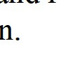
Thus, the problem of HS pathogenetic mechanisms investigation as well as new strategies to influence the mechanisms of brain damage finding remains urgent and requires a comprehensive study. To solve this idea, it’s quite important to deal with two main tasks: (a) to investigate the efficacy of calcium channels blockers in both the experimental primary and recurrent HS and (b) to identify the influence of the methodological factors determining HS manifestation.
The purpose of the study was to identify the relationship between the neurological status methods of investigation and pharmacological treatment with experimental animal’s behavioral and cognitive disorders and mortality in conditions of primary and recurrent hemorrhagic stroke.
Materials and methods. Experimental studies were performed on 312 white male Wistar rats weighing 180–220 g. The animals were kept in standard vivarium conditions. Experimental animals keeping and manipulation was done in accordance with the “General Ethical Principles of Animal Experiments” adopted by the First National Congress on Bioethics (Kyiv, 2001), and was guided by the recommendations of the European Convention for the Protection of Vertebrate Animals for Experimental and Other Scientific Purposes (Strasbourg, 1985) and guidelines of the State Pharmacological Center of the Ministry of Health of Ukraine on “Preclinical studies of drugs” (2001) as well as rules of humane treatment of experimental animals and conditions approved by the Committee on Bioethics of Odesa National Medical University (Prot. No. 17-C from 12.11.2021).
We used the model of acute HS and the model of recurrent (repeated HS). Brain tissue of the rats anesthetized by sodium thiopental (PАО “KyivMedPreparat”, Ukraine; i.p., 60 mg/kg) within the right inner capsule (AP=0.6–1.0; L=3.5–4.0; H=6.0) in rats fixed in the stereotaxical device was destructed mechanically using mandren-knife with additional autologous blood (0.10–0.15 ml) introduction into the area of destruction [6]. The recurrent HS was modeled by the same method 1 month after the primary one.
All animals were randomized into 5 subgroups and finally were divided into 3 groups: group I – control animals (n=20); group II – experimental animals with primary HS [(subgroup IIA – rats with primary HS without pharmacological treatment, n=104) and (subgroup IIB – rats with primary HS using calcium channel blockers administration, n=58)]; group III – experimental animals with recurrent HS [(subgroup IIIA – rats with recurrent HS without pharmacological treatment, n=72) and (subgroup IIIB – rats with recurrent HS using calcium channel blockers administration, n=58)].
Verapamil hydrochloride (PAO “Darnitsya”, Ukraine; i.p., 0.1 mg/kg) was administered for 10 days to block calcium channels in the experimental animals.
Animals’ neurological status was evaluated 3, 7, 14, 21 and 30 days after HS modulation using Buresh method of “postural reactions” analysis, modified scale of neurological disorders severity measurement (NDSM) and McGraw Stroke Index scale [1]. Rats’ behavior was studied in the “Open Field” test, cognitive functions were assessed in the test of conditioned reaction of passive avoidance [1].
The data obtained were calculated statistically using one-way variant ANOVA parametric criterion accompanied by a post-hoc Newman-Keuls test. The minimum statistical probability was determined at p<0.05.
Results of the study and their discussion. The general condition of the animals, the development of neurological deficits, mortality and the used pharmacons impact on these indicators were monitored throughout the experimental trial. In all experimental animals with experimental HS, manifestations of varying degrees of motor activity disorders were observed, mainly hemiparesis of the contralateral extremities, need for food and water. The dynamics of mortality of rats within 30 days after modeling of primary HS in the assessment of changes in “postural” Buresh reactions and behavioral reactions in the “Open Field” test did not differ: the total 30-day mortality was 34.8±9.93 % (P±m_{p} %), and the largest was observed on the 3rd day after the reproduction of the pathological condition (13.0±7.02 %, Table 1).
Table 1 The influence of pharmacological treatment with verapamil on rate of mortality (number) in rats with primary HS
Group | “Postural” reactions by Buresh |  |  |  | “Open field”
IIA | Days | Number of rats |  |  | Number of rats
IIA | Days | Primary quantity | Mortality |  | Primary quantity | Mortality
IIA | Days | 23 | Abs | P±m_{p} % | 23 | Abs | P±m_{p} %
IIA | 3 | 20 | 3 | 13.0±7.0 | 20 | 3 | 13.0±7.0
IIA | 7 | 19 | 1 | 4.3±4.3 | 19 | 1 | 4.3±4.3
IIA | 14 | 19 | 0 | 0.0±0.0 | 19 | 0 | 0.0±0.0
IIA | 21 | 17 | 2 | 8.7±5.9 | 17 | 2 | 8.7±5.9
IIA | 30 | 15 | 2 | 8.7±5.9 | 15 | 2 | 8.7±5.9
IIA | Total mortality |  | 8 | 34.8±9.9 | Total mortality | 8 | 34.8±9.9
IIIA | Days | Primary quantity | Mortality |  | Primary quantity | Mortality
IIIA |  | 15 | Abs | % | 15 | Abs | %
IIIA | 3 | 12 | 3 | 20.0±10.33 | 12 | 3 | 20.0±10.33
IIIA | 7 | 11 | 1 | 6.7±6.44 | 11 | 1 | 6.7±6.44
IIIA | 14 | 9 | 2 | 13.3±8.78 | 9 | 2 | 13.3±8.78
IIIA | 21 | 7 | 2 | 13.3±8.78 | 8 | 1 | 6.7±6.44
IIIA | 30 | 5 | 2 | 13.3±8.78 | 8 | 0 | 0.0±0.0
IIIA | Total mortality |  | 10 | 66.7±12.2 | Total mortality | 7 | 46.7±12.9
Group | Mc Graw Stroke Index scale |  |  |  | NDSM scale
IIA | Days | Primary quantity | Mortality |  | Primary quantity | Mortality
IIA |  | 22 | Abs | P±m_{p} % | 20 | Abs | P±m_{p} %
IIA | 3 | 18 | 4 | 18.2±8.2 | 18 | 2 | 10.0±6.7
IIA | 7 | 16 | 2 | 9.1±6.1 | 16 | 2 | 10.0±6.7
IIA | 14 | 15 | 1 | 4.5±4.4 | 15 | 1 | 5.0±4.9
IIA | 21 | 13 | 2 | 9.1±6.1 | 14 | 1 | 5.0±4.9
IIA | 30 | 12 | 1 | 4.5±4.4 | 13 | 1 | 5.0±4.9
IIA | Total mortality |  | 10 | 45.4±10.6 | Total mortality | 7 | 35.0±10.7
IIIA | Days | Primary quantity | Mortality |  | Primary quantity | Mortality
IIIA |  | 12 | Abs | P±m_{p} % | 13 | Abs | P±m_{p} %
IIIA | 3 | 10 | 2 | 16.7±10.7 | 11 | 2 | 15.4±10.0
IIIA | 7 | 8 | 2 | 16.7±10.7 | 9 | 2 | 15.4±10.0
IIIA | 14 | 7 | 1 | 8.3±8.0 | 7 | 2 | 15.4±10.0
IIIA | 21 | 6 | 1 | 8.3±8.0 | 5 | 2 | 15.4±10.0
IIIA | 30 | 5 | 1 | 8.3±8.0 | 4 | 1 | 7.7±7.4
IIIA | Total mortality |  | 7 | 58.3±14.2 | Total mortality | 9 | 69.2±12.8

In the experimental group of animals after re-simulation of stroke there was an increase in mortality of rats: taking into account the method of Buresh – 66.7±12.2 %, open field – 46.7±12.9 %. The highest mortality rates were observed on the 3rd day and they equal 20.0±10.3 %. At the stages of assessing the development of neurological deficits that were evaluated on the NDSM and McGraw scales, similar dynamics of mortality was observed in the experimental groups, but some differences were observed depending on the episode of HS.
In the group of rats with primary HS, the overall 30-day mortality in the subgroup of rats evaluated on the NDSM scale was 35.0±10.67 %, and in the McGraw evaluation – 45.4±10.62 %. Three-day mortality, respectively, indexes were equal to 10.0±6.71 % and 18.2±8.22 %.
In the group of rats after the re-simulation of stroke, a different trend was observed: the average mortality at the stages of pathophysiological study was 58.3±14.2 % in the subgroup after McGraw and 69.2±12.8 % in the subgroup with the assessment of neurological deficit on the NDSM scale. The highest mortality of animals was registered in the observation period of 3-7 days after the pathological condition reproduction.
The above differences in the mortality rates of experimental animals in the conduct of pathophysiological studies should not be considered in terms of the impact of the measures used on the viability of animals, but may be taken into account for further experimental studies. Nevertheless, in all research groups the maximum mortality on the 3rd day of the experiment and the tendency of exacerbation on the 21st day was found, which was reflected in the relevant indices (Table 2).
Table 2 The influence of pharmacological treatment with verapamil on rate of mortality (number) in rats with recurrent HS
Group | “Postural” reactions by Buresh |  |  |  | “Open field”
IIA | Days | Number of rats |  |  | Number of rats
IIA | Days | Primary quantity | Mortality |  | Primary quantity | Mortality
IIA | Days | 11 | Abs | P±m_{p} % | 12 | Abs | P±m_{p} %
IIA | 3 | 9 | 2 | 18.2±11.6 | 11 | 1 | 8.3±8.0
IIA | 7 | 9 | 0 | 0.0±0.0 | 9 | 2 | 16.7±10.6
IIA | 14 | 8 | 1 | 9.1±8.7 | 8 | 1 | 8.3±8.0
IIA | 21 | 8 | 0 | 0.0±0.0 | 8 | 0 | 0.0±0.0
IIA | 30 | 7 | 1 | 9.1±8.7 | 8 | 0 | 8.3±8.0
IIA | Total mortality |  | 4 | 36.3±14.5 | Total mortality | 4 | 33.3±13.6
IIIA | Days | Primary quantity |  | Mortality | Primary quantity | Mortality
IIIA |  | 10 | Abs | P±m_{p} % | 11 | Abs | P±m_{p} %
IIIA | 3 | 9 | 1 | 10.0±9.5 | 9 | 2 | 18.2±11.6
IIIA | 7 | 8 | 1 | 10.0±9.5 | 7 | 2 | 18.2±11.6
IIIA | 14 | 7 | 1 | 10.0±9.5 | 5 | 2 | 18.2±11.6
IIIA | 21 | 6 | 1 | 10.0±9.5 | 5 | 0 | 0.0±0.0
IIIA | 30 | 6 | 0 | 0.0±0.0 | 5 | 0 | 0.0±0.0
IIIA | Total mortality |  | 4 | 40.0±15.5 | Total mortality | 6 | 54.5±15.0
Group | Mc Graw Stroke Index scale |  |  |  | NDSM scale
IIA | Days | Primary quantity |  | Mortality | Primary quantity | Mortality
IIA |  | 10 | Abs | P±m_{p} % | 10 | Abs | P±m_{p} %
IIA | 3 | 9 | 1 | 10.0±9.5 | 8 | 2 | 20.0±12.7
IIA | 7 | 8 | 1 | 10.0±9.5 | 8 | 0 | 0.0±0.0
IIA | 14 | 8 | 0 | 0.0±0.0 | 8 | 0 | 0.0±0.0
IIA | 21 | 8 | 0 | 0.0±0.0 | 7 | 1 | 10.0±9.5
IIA | 30 | 8 | 0 | 0.0±0.0 | 7 | 0 | 0.0±0.0
IIA | Total mortality |  | 2 | 20.0±12.7 | Total mortality | 3 | 30.0±14.5
IIIA | Days | Primary quantity |  | Mortality | Primary quantity | Mortality
IIIA |  | 12 | Abs | P±m_{p} % | 10 | Abs | P±m_{p} %
IIIA | 3 | 10 | 2 | 16.7±10.7 | 8 | 2 | 20.0±12.7
IIIA | 7 | 8 | 2 | 16.7±10.7 | 7 | 1 | 10.0±9.5
IIIA | 14 | 8 | 0 | 0.0±0.0 | 6 | 1 | 10.0±9.5
IIIA | 21 | 8 | 0 | 0.0±0.0 | 6 | 0 | 0.0±0.0
IIIA | 30 | 8 | 0 | 0.0±0.0 | 6 | 0 | 0.0±0.0
IIIA | Total mortality |  | 4 | 33.3±13.6 | Total mortality | 4 | 40.0±15.5

Summarizing the data obtained, we can say that the mortality of experimental groups of rats depends on the episode of simulation of experimental HS. Thus, the 30th-day mortality rate at primary stroke was 37.5±5.1 % (33 of 88 animals), and after the recurrent one – 60±6.6 % (33 of 55 animals). In groups of experimental animals, which after the pathological condition modelling the calcium channels blockers were administered, a positive effect of pharmacocorrection on the viability of rats was found (table 2).
The total 30-day mortality in group IIB was within 36.3±14.5 %, and in group IIIB it ranged from
33.3±13.6 % to 54.5±15.0 %. In the case of primary stroke (group IIB), the highest mortality was observed
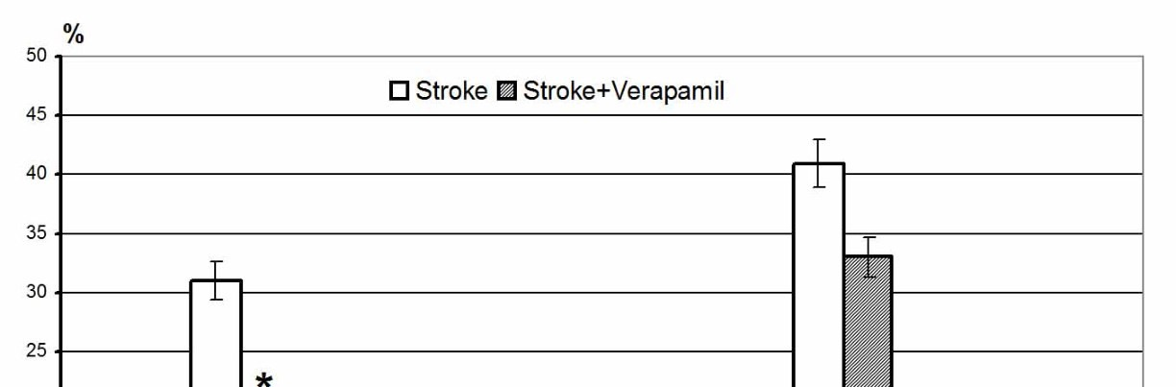
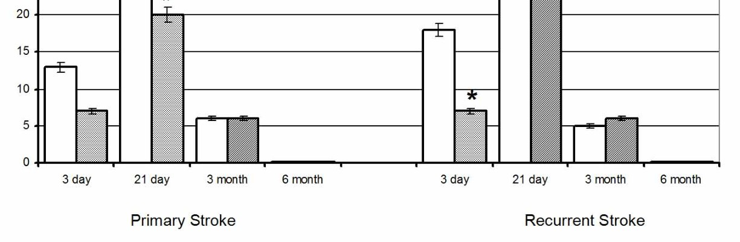
on day 3, and in case of repeated stroke (group IIIB), prolonged mortality was observed in experimental rats during 3-14 days of observation. The obtained data may indicate that that the introduction of CCB affected changes in systemic and regional hemodynamics, which affected the viability of experimental animals.
Analysis of mortality of experimental animals for a 6month follow-up period showed a negative dynamic of the growth of this indicator in case of recurrent stroke. The main mortality rate was
Fig. 1. The indexes of rat’s mortality in conditions of primary and recurrent  hemorrhagic strokes comparing with the analogous indexes after verapamil administration. Note: * – p<0.05 – the significant differences of the investigated indexes compared with the | recorded in the acute period of stroke, i.e., up to 21 days after the
analogous data in the same time intervals in rats without the treatment (ANOVA test).) ACA reproduction (fig. 1).
The overall mortality on the 180th day in the group of rats with primary stroke reached 50.0±12.5 %, and in the group with recurrent stroke – 64.7±11.59 %. There was a decrease in rats mortality after primary and recurrent stroke after verapamil administration, respectively, to 40.0±12.65 % and 46.6±12.88 %. It should be stressed that we found statistical confirmation of mortality rate decrease both on the 21st days of experiment (on 11.2 % and 7.8 % depending on the episode of HS, p<0.05) and on the end of the trials (on 20.0 % and 28.0 %, correspondently, p<0.05; fig. 2).
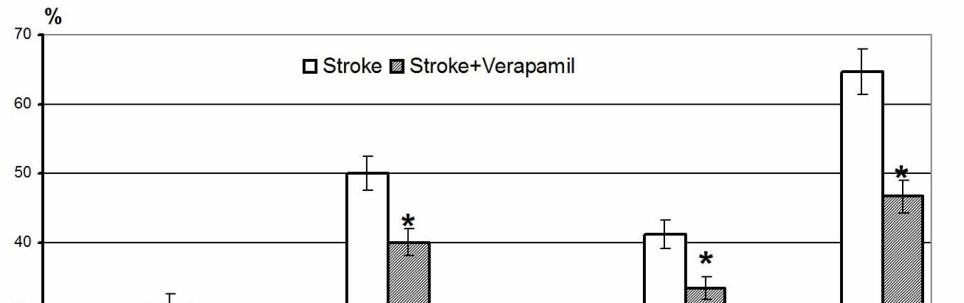
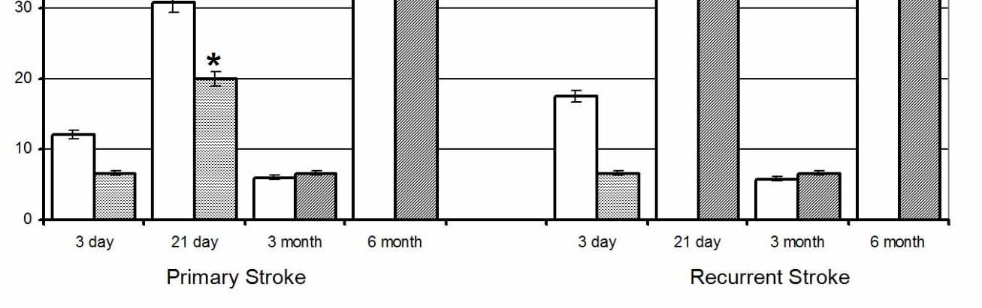
Thus, the data obtained can be analyzed as follows. The first block of our results indicates the animal mortality dependence on the method of hemorrhagic stroke reproduction. In this case, mortality rates were twice lower in the group of animals with primary HS. These data are consistent with similar results of clinical observations [7, 15] and in our case emphasize the purity of the pathophysiological experiment and the validity of the data obtained. We suppose interesting another block of results which
Fig. 2. The influence of pharmacological treatment with verapamil on rats with  primary and recurrent hemorrhagic strokes indexes of six-month mortality. Note: * – p<0.05 – the significant differences of the investigated indexes compared with the analogous data in the same time intervals in rats without the treatment (ANOVA test). | clearly demonstrates the HSinduced animals mortality de- pendence on the pathogenetically
based pharmacocorrection. Calcium channel blocker verapamil direct positive effect on the investigated index was revealed in two series of observations.
Taking into account the known verapamil efficacy mechanisms realization one could speculate about the leading calcium-dependent mechanism of HS pathogenetic chain.
Our results also proved that acute stroke pathogenesis activates the mechanisms of the glutamatecalcium cascade, scientists are discussing their diversity in different periods of pathological process [3, 5, 13, 14]. It is known that calcium ions play the role of a trigger factor in cellular damage processes [8]. We showed calcium-channels participation in chronic epileptogenesis initiation and their blockade importance in case of antiepileptic efficacy achievement [2].
Therefore, in our opinion, one of the pathogenetically justified ways of pharmacological influence on the development of cytonecrotic processes in HS is the calcium channel blockade, which affects the functional activity of calcium channels, because, on the one hand, calcium channels are involved in cerebral vessels’ tone regulation, and on the other – in the implementation of the neurotoxic effect of excitatory aminoacids [5].
We consider the received data as an experimental background of reasonability of calcium channels
blockers effects testing in clinical conditions at hemorrhagic strokes.

Conclusions
- The data obtained showed the animal mortality dependence on the method of hemorrhagic stroke reproduction. In this case, mortality rates were twice lower in the group of animals with primary HS.
- We demonstrated HS-induced animals mortality dependence on the pathogenetically based pharmacocorrection. Calcium channel blocker verapamil direct positive effect on the investigated index was revealed in two series of observations.
- Taking into account the known verapamil efficacy mechanisms realization one could speculate about the leading calcium-dependent mechanism of HS pathogenetic chain.
- We consider the received data as an experimental background of reasonability of calcium
channels blockers effects testing in clinical conditions at hemorrhagic strokes.

Prospects for furthers researches include a subsequent comprehensive experimental studies and clinical observations to determine the calcium channel blockers administration rationality, time and dosages for therapeutic purposes in primary and recurrent hemorrhagic stroke. A clear scheme of primary and recurrent hemorrhagic stroke complex pathogenetically substantiated therapy should be a result of these studies.

Стаття надійшла 29.08.2021 р.

