Kiev Medical University of UAFM

Department of Internal medicine and Occupational diseases.

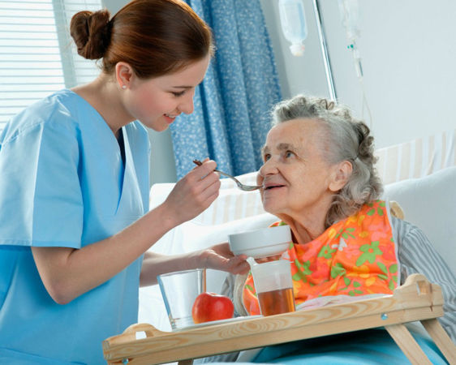

General Care of a Patient (Manual Part 1)

Edited by Head of Department: Prof.Batushkin.V.V
Author:Assistant of Department: Doctor Mozhdehi.Z.K

Kiev
2017

CONTENT :

Unit 1
Theme 1. Importance of the general care of a patient .
Theme 2. Reception and hospitalization of patients.
Theme 3. Personal hygiene of a patient.
Unit 2
Diet and nutrition.
Unit 3
Theme 1. Body temperature, temperature measurement and nursing in
feverish patients.
Unit 4
Theme 1. Nursing Patients with Respiratory Diseases.

UNIT 1
Theme 1.
IMPORTANCE OF GENERAL CARE OF A PATIENT
Goal: to get the notion about the job of a nurse, the importance of patient’s care, legislative bases of health protection.
Knowledge objectives: - to know the history of profession of a nurse, qualification requirements in profession of a nurse, official duties of a nurse, the role of the general care of a patient as a medical factor, rules of behavior in a clinic or a hospital.
Subject-matter:
1) history of the profession of a nurse;
2) the importance of care of a patient as a medical factor;
3) relationship between medical staff and patients;

The importance of the patient’s care is great. A nurse should strictly follow the doctors instructions, carry out all the actions promoting preservation and recovery of patient’s health, relieve his sufferings, thoroughly watch the functioning of all the organs, prevent possible complications and approach tactfully to a patient. Only then, the recovery of patients with different degree of severity and with various diseases is possible.
History of the organization of the system of nurse training.
The work of a medical nurse has a century-old history. Hippocrates had much to say about what is now called nursing. The first and best known of his Aphorisms is the following: “Life is short, and Art is long; occasion is fleeting; experience is fallacious, and judgement is difficult. A physician must not only be prepared to do what is right himself, but must also make a patient, attendants, and externals to co-operate”. In the Midieval Ages, several religious orders provided and staffed hospitals. Such organizations included both help to a patient and control of epidemics.
The Order of Saint Lazar patronized the leprotics, the Order of Saint Joan was in charge of patients in Jerusalem in 1099. The basic care of such organizations included both help to a patient and control of epidemics. In the 14th century, there appeared religious associations of women nursing the patients. In the 17th century,charitable societies came into being and the term “nurse” (the sister of mercy) appeared. In Russia, the alms-houses called to render the charitable medical help opened at monasteries and hospital wards were created there. People began to call a place where the pain (Russian «боль» – [bol’]) stacks a person down (Russian «ниц» - [nitz]) as a hospital (Russian «больница» - [bol’nitza]). In Russia, women began to take care of the sick and wounded under Peter the First (1672-1724). Under Emperor Paul the First (1754-1801), the Widow houses were created where compassionate widows gratuitously took care of patients free-of charge hospitals for the poor. The first Russian community of nurses appeared in 1844 on the initiative of Nikolay(the first princess) and the great princess Alexandra Nikolaevna in Saint Petersburg.
In 1854 during the Crimean war (1853 - 1856) under the guidance of the great princess Elena Pavlovna, who organized help for the wounded on battlefield. Khrestovozdvijenskaya community of nurses was set up. Dasha Sevastopolskaya name is closely connected with the modern nursing era in Russia. Using her own intuition, she set up a care plan for each wounded man. Thus the first dressing station was organised in the Crimean War. The brilliant Russian surgeon professor Nickolay Pirogov, who took part in the Crimean War, asked Dasha to assist him during surgeries. She worked side by side with him. The outstanding Russian surgeon N.I.Pirogov worked out community regulations and special instructions for nurses who were divided into groups (dressing, watching, pharmaceutical and auxiliary nurses). He worked out the principles of sorting the wounded and the sick to improve the medical aid. Therefore it’s N.I.Pirogov who is justly considered to be the first organizer of the nurse service in Russia.
The term “nurse care” was offered by the legendary Florence Nightingale in 1859, and in 1865 this term was accepted by the International Committee of the Red Cross. Florence Nightingale set up a military hospital in November 1854 (the Crimean war). She instilled strict order in hospitals, rational feeding of the wounded, organized teaching for nurses and assisted herself at operations. After the war, Florence Nightingale presented to Queen Victoria the developed plan of a hospital-services reformation and established the school at St. Thomas’s Hospital in London, which became the model for schools of nursing everywhere. In the 20th century, laws have been passed in nearly all countries to regulate the training and registration of nurses.
In Russia and Ukraine, nursing training is carried out in medical schools and colleges. Quality of medical aid to the population depends on the training of medical staff. It also concerns the students of medical universities. Insufficient preparation for lessons and bad knowledge of various sections of the general care can result in mistakes in their further work as doctors.
Importance of patient’s care
The importance of care of the patient is difficult to estimate. Exact performance of doctor's instructions, carrying out all the actions promoting preservation and recovery of patient’s health, relieving patients sufferings, thorough watching of all the organs functioning, prevention of probable complications, tactful approach to a patient etc., all contains the concept of care of a patient. Precise performance of doctor's instructions, strict observance of dietary, water hygienic regimes, favorable physical and psychological conditions are capable to improve health even incurable patients. On the contrary, bad care as a result of negligent attitude of a nurse to her direct duties do not only delay recovery of a patient but also aggravate the severity of his condition. The daily life care of a patient means rendering the help in various needs such meal, drink, toilet, movement, physiological necessity etc.
The care also means creation of the optimum conditions both in medical institution and at home such as silence and rest, comfortable bed, clean linen, fresh air etc. Such care is usually carried out by attendants and relatives of a patient. In medicine, the concept of care of a patient is treated more widely. It is detached from independent discipline and represents the whole system of measures , including correct and timely fulfillment of various medical prescriptions, carrying out diagnostics, preparation of the patient for the necessary examinations, observation of the patient condition, rendering the first pre-medical help, conducting of the necessary medical documentation. Quite often, the success of treatment is entirely determined by quality of care. For example, it is possible to perform a complicated operation and to achieve a significant recovery of the disordered extremity functions after stroke or fracture, but is possible to lose a patient because of congestive or inflammatory processes in the lungs as a result of long immobility, bedsores caused by bad care. Therefore the care of a patient is an obligatory component of treatment influencing on the cause of the disease and recovery of a patient.
Relations between medical staff and patients
Moral code, norms of behavior of a nurse ,certain norms of ethics and morals are inherent to medicine. The term “ethics” (Greek “ethice” - study of morals and morality) was first offered by the ancient Greek philosopher Aristotle, identifying it with a notion about human morals and ethics. The synonym to the term “medical ethics” is a notion of medical deontology (Greek “deontos” - duty, “logos” - teaching), introduced by the English philosopher Bentam in the XVIII century. Medical ethics covers a wide range of problems and include various questions of mutual relation of the doctor and the patient, the doctor and relatives of a patient and medical workers themselves.
Deontological problems increase in connection with wide introduction of results of scientific and technical progress into practical medicine. Education of students in a higher medical school requires the observance of some ethical standards. More detailed acquaintance with various aspects of medical ethics is taught as students progressed to senior courses. The principal questions of medical ethics are mutual relations between a doctor and a patient. In many respects a sick man qualitatively differs from a healthy person. Condition of a person during stress, emotional experience, hope or disbelief in recovery creates a special atmosphere of relations between a medical worker and a patient. For medical workers, be it a nurse, an attendant or a medical student, such human qualities with tactful approach, sympathy, kindness, cordiality, care and attention are required. The listed personal qualities of medical workers, who take care of patients, should be supported with education and high professionalism. Deontology principles foresee the fulfillment of concrete requirements to general appearance of a medical worker: it is necessary to use replaceable footwear, the gown should be clean and ironed, nails -shortly cut, hair - filled under a cap. The care also assumes the observation of certain rules of contact with a patient. It is important to give the patient a maximum of attention, to calm him or her down, to explain the necessity of following a regime and taking medicines regularly and to convince the patient of an opportunity of recovery or improvement of condition. It is necessary to observe caution while speaking with the patients, especially with those suffering from oncological diseases; it is not wise to let them know their true diagnosis.
Nowadays, the statement of the great doctor of the antiquity and the father of medicine Hippocrates is true as ever. He said Surround the patient with love and a reasonable consolation, but leave him ignorant to what threatens him. Nevertheless, in some countries, the patient is informed on gravity of the disease and possible lethal outcome, originating from social and economic reasons. Thus, in the USA the patient has even the right to make a proceeding against the doctor who had concealed the diagnosis of cancer from him. Violation of deontological principles of contact with patients can cause the development of iatrogenic diseases (Greek “jatros” - doctor, “gennao” - bear, cause). Iatrogenic disease is a pathological state of a patient caused by careless statements or acts of the doctor or other medical worker which was created such a result of a patient a feeling the presence of some disease or special severity of the disease. Inadequate, harmful verbal contacts are injurious to the patient and can cause various psychogenic iatrogeny. However 300 years ago, the English Hippocrates, T. Sidenhem accentuated the danger to the patient not only because of the actions of a medical worker, injuring a patient’s mentality, but also due to undesirable consequences of medical manipulations. Nowadays any diseases which occur because of the actions of medical workers are considered to be iatrogenic. Besides the psychogenic iatrogeny (iatropsychogeny) there is iatropharmacogeny (consequence of medicamental influence on the patient - for example, after-effects of drugs), manipulation iatrogeny (unfavorable influence on the patient during his examination - for example, complications in coronaroangiography), combined iatrogeny (consequences of the influence of several factors) and the so-called dumb iatrogeny (consequence of inactivity of medical workers). The necessity to keep a medical secret can also be referred to the deontological problems of care. Medical workers have no right to divulge any information about the patient’s personal life. But this requirement does not refer to the situations that may cause danger to other people (infectious, sexually transmitted diseases (STD or venereal diseases), acquired immune-deficiency syndrome (AIDS), poisonings etc.). In these cases, medical workers are obliged to inform the appropriate organizations on the received data immediately. With the purpose of realization sanitation and epidemiologic actions in the focus at revealing pediculosis, an infectious disease or food poisoning, the nurse is obliged to inform the Sanitation and Epidemiologic.

UNIT 1
Theme 2: BASIC TYPES OF MEDICAL INSTITUTIONS

To make medical aid for workers more available in the infirmaries
Goal: to get notion about treatment and preventive institutions, about in-patient and out-patient medical aid.
Knowledge objective:
To know the kinds of medical aid rendered by medical institutions of various type.
Subject-matter:
- Basic types of the treatment-and-preventive institutions rendering out-patient aid,
- Basic types of the treatment-and-preventive institutions rendering in-patient medical aid.

EDUCATIONAL MATERIAL:

The basic types of medico-prophylactic institutions, rendering out-patient medical aid
Medical aid to the population of Russia is provided with various types of treatment-and-preventive institutions and can be out-patient, hospital, sanatorium, ambulant and emergency.
Medical aid is rendered both at a place of permanent residence (polyclinics, hospitals) and at a place of work (medical institutions of the enterprises). Polyclinics, polyclinic departments of clinics, out-patient stations, medico-sanitary parts and infirmaries, ambulance stations and female consultation service carry out the out-patient help in cities.
An out-patient clinic (Latin “ambulatorius” – mobile) is a treatment-and-preventive institution rendering out-patient medical aid to the population of a small settlement of the city type, a small industrial enterprise or countryside. In countryside, the out-patient help can be rendered by a nursing and midwife station. Reception of patients in an out-patient clinic is carried out only on the basic specialities (a physician, a surgeon, a dentist, a gynaecologist etc.). The district principle of work allows to evaluate the sick, to render the qualified help to them, to study the disease incidence, to carry out preventive and sanitary - educational work. The out-patient clinic differs from a polyclinic (see below) in less number of experts and in the volume of activity.
In large industrial enterprises, medical aid is rendered by medico-sanitary units which can include a hospital, an out-patient department, an infirmary and a dispensary. To make medical aid for workers more available, the infirmaries are included into the structure of the industrial enterprise or medico-sanitary unit are organized at industrial enterprises. The doctor’s infirmary is headed by a doctor, a nursery infirmary - by a doctor’s assistant or a nurse.
An infirmary is a division of a medico-sanitary unit or a polyclinic, organized at industrial enterprises, buildings, at high and secondary educational institutions, schools. Along with rendering the first medical aid in traumas, sudden diseases and professional poisonings, the infirmary carries out systematic sanitary and hygienic and treatment-preventive actions to prevent and decrease the disease incidence.
Polyclinic (Greek “polis” - city, “klinike” - art of treating) - the multiprofile treatment-and-preventive institution in which the medical aid, including specialized one, is rendered to visiting patients and also to patients at home. Complex of treatment-and-prophylactic measures to treat and prevent diseases and their complications is carried out as well. The polyclinic is an independent treatment-and-prophylactic institution of a city type or a part of a medico-sanitary unit or the incorporated hospital. In a polyclinic reception of patients by doctors of all specialities is carried out. There are laboratories, diagnostic and medical consulting rooms. Patients who can’t come to a polyclinic, call a doctor to their residence where they get the qualified help, and in case of necessity are hospitalized. The polyclinic reveals the sick, renders assistance, examines disease incidence, and carries out routine inspections.
There are also rooms of pre-medical reception in polyclinics where a nurse takes a patient’s temperature and measures his arterial pressure.
Out-patient - polyclinic institution carries out also prophylactic medical examination, i.e. active medical supervision of a certain contingent of the population.
Dispensary (Latin “dispenso” - to distribute) – is a specialized treatment-and-prophylactic institution working on a dispensary method. Dispensary serves the patients with certain groups of diseases: cardiological, oncological, psychoneurological, endocrinological, dermatovenereal etc.Along with treatment and prevention, dispensary carries out home nursing of patients - active regular visiting at-home, sanitary-educational work, performance of medical prescriptions.
On the basis of large versatile hospitals, clinics, medical academies, medical universities and research institutes ensuring highly skilled out- patient examination and in-patient treatment.
Female dispensary is a treatment-and-prophylactic institution in which treatment, prevention of gynaecological diseases and supervision of the pregnant women is carried out. The midwife assists the doctor at reception of patients, conducts home nursing of pregnant women, trains them to care for the newborn and personal hygiene. She carries out both prescriptions of the doctor and sanitary - educational work.
Ambulance stations (or stations of emergency aid) provide medical aid in emergency cases, working round the clock (24 hours). The medical assistant going on calls, rendering first aid and hospitalizing a patient can be at the head of the team. Specialized medical aid demanding high qualification is given by the team headed by the doctor, while a medical assistant helps him to render assistance and transport a patient. Many ambulance stations have special cars with the modern equipment that allows to render the emergency help and to carry out resuscitation actions on the way to a hospital.
The basic types of treatment-and-preventive institutions,
rendering in-patient medical aid
Stationary (Latin “stationarius” - motionless) medical aid is rendered to a patient requiring regular supervision, complex methods of examination and treatment are necessary. There are several kinds of stationary institutions.
Hospital is a treatment-and-preventive institution that provides highly skilled service to the population on the basis of the achievements of modern medical science and engineering. A city hospital can be versatile for the treatment of patients with various diseases and can be specialized for the treatment of certain diseases (tuberculosis, infections, mental diseases etc.). The regional or republican hospital provides the rural population with the highly skilled specialized polyclinic and stationary medical aid.
The clinic is a hospital institution where both hospitalization of patients and research work and education of students, doctors and the secondary medical staff are carried out.
Military hospital is a hospital for the treatment of military men and invalids of war.
Sanatorium (Latin “sanatum” - to treat, to cure) is a stationary
institution where rehabilitation of patients is carried out. Sanatoria are usually situated in a place (health resorts) with favourable climate where there are mineral waters and medical mud.

CONTROL QUESTIONS
1. What types of medical institutions exist in Russia?
2. What medical institutions render out-patient help?
3. What are the principles of work in an out-patient clinic and an infirmary?
4. What treatment-and-preventive help is rendered by a polyclinic?
5. What work is carried out by dispensaries and diagnostic and consultation clinics?
6. What work is carried out by female consultation service and ambulance stations?
7. What medical institutions render the in-patient help?
8. Tell about the work of the institutions rendering in-patient medical aid.

Theme 2
RECEPTION and HOSPITALIZATION of PATIENTS:
Goal: to get a notion about the rules of the emergency department (admitting department, reception ward) and hospitalization of patients at medical institution, about the structure of the emergency department, sanitary-and-epidemiologic regimens of emergency department; to master skills. Knowledge objectives: - to know the arrangement and equipment of the emergency department, duties of a nurse and a junior nurse, the rules of reception and registration of patients, filling in passport data into a case history (medical card, record card), inspection of skin and hair covering, disinsection of a patient in pediculosis detection, sanitization of patients (complete and partial); Skill objectives: - to develop practical skills in rendering hygienic baths, anthropometry (weighing a patient, measurement of height, measurement of the chest circle), transportation of a patient by a wheelchair and a stretcher.
Subject-matter:
1) an emergency department of the hospital;
2) reception and registration of patients;
3) sanitization of a patient at the emergency department;
4) the order of hospitalization, the basic methods and ways of transportation of patients to departments;
5) practical skills. Equipment required: tables, a log-book of reception of patients, a case history, a statistical card, journal of refusals in hospitalization, medical weight-scale, height meter, a wheelchair, a wheel-stretcher, a stretcher.

EDUCATIONAL MATERIAL
“Hospital is a place of shelter where sick people are taken care of and where they can be admitted” F.Nightingale The emergency department is an important treatment and diagnostic department of a hospital. At the emergency department medical documentation (case history, registration book) is filled in; primary examination, anthropometry (from Greek: anthropos - a person, metreo - to measure) and sanitization of the admitted patients are carried out, in case of need the medical aid is rendered. Success of the subsequent treatment of a patient, and in urgent cases the life of a patient depend to a certain degree on how professionally, quickly and effectively the medical staff of this department operates.
The emergency department of a hospital.
The emergency department is a part of a hospital intended for registration, reception, examination, sanitization of delivered patients and rendering the urgent medical aid. Every delivered patient should feel the careful and friendly attitude at the emergency department. Then he will trust the institution where he will be treated. The emergency department consists of a waiting hall, registration room, rooms for patient’s examination (one or several), a sanitary inspection room, a procedure room, a dressing room. Large hospitals have a small operating room, a casualty room, an X-ray room, a laboratory. The emergency department should include an isolator for patients with a suspected infectious disease.
The work of the emergency department is kept to a strict order:
1) registration of patients;
2) medical examination;
3) sanitization. Rooms should be placed in the same sequence.
The waiting hall is intended for patients who are not bedfast, and for relatives accompanying them. Table and many chairs should be here. The wall information board indicates the working hours of medical departments; doctor’s consulting hours for relatives, the list of food parcels allowed for a patient. The registration room is situated nearby (here registration of admitted patients and registration of the necessary documentation are made. The inquiry office is also situated nearby. In a room for patients examination a doctor examines a patient, makes an initial diagnosis, determines a kind of sanitization. Here thermometry, and sometimes other examinations (for example, electrocardiography) are carried out. If a patient is admitted in severe or unconscious condition, he is given an immediate help, without losing time for registration; all the necessary data are got later from a patient, relatives or persons accompanying him. Procedure room, dressing room, and also a small operating room are intended for rendering the emergency aid. For sanitization of patients admitted to a hospital, the emergency department has a sanitary inspection room (a bath, shower, a room for changing clothes etc.).
Reception and registration of patients:
To the emergency department patients can be delivered:
1) by ambulance (in accidents, traumas, acute diseases and exacerbation of chronic diseases);
2) by the direction of a district doctor (in inefficient treatment in home conditions) – for planned hospitalization; before MSEC (medical social expertise commission) examination, and also by the direction of a military registration and enlistment office;
3) by transferring from other treatment-and-prophylactic establishments (under the arrangement with administration);
4) "by themselves" (the independent address for help of a patient in case of becoming worse in a street near a hospital).
A doctor of the emergency department examines a patient and decides on his hospitalization.
After that a nurse fills in the medical documentation.
A nurse takes a patient’s temperature and writes down patient’s personal data (surname, first name, date of a birth, home address), when and who delivered him, the diagnosis put by the directing institution, the initial diagnosis of the emergency department and the department a patient is directed to in “The Log-book of reception of patients” or “The Registration book” (form 001/u). She fills in the title page of the Case history of a patient (form 003/u), the passport data and the left part of the Statistical card of the discharged patient (form 066/u).
If a patient is delivered to the emergency department in poor condition, then besides registration a nurse must render a patient the first pre-medical aid, urgently call a doctor and quickly fulfil all doctor’s prescriptions.
If a patient is delivered to the emergency department from a street in an unconscious condition and without documents a nurse after a doctor’s examination renders him emergency medical aid and fills in the necessary documents. After that she must give a telephone message to a police station and a bureau of accidents. In a telephone message patient’s data (sex, approximate age, height and constitution) and a patient’s clothes must also be noted. Before a patient’s identification he should be registered as “unknown” in all the documents. In “The Book of telephone messages” the text of the telephone message, date, time and a recipient of the message must be recorded.
A nurse must also give a telephone message to relatives and make the appropriate record in «The Book of telephone messages» in the following cases: а) a patient is delivered to a hospital because of a
sudden disease occurred outside his home; b) a patient died at the emergency department.
When after examination and observation of a patient by a doctor there are no indications to hospitalization, a patient can go home. A nurse does a record in « The Book of refusals in hospitalization » (the same form with « the Log-book of reception of patients» 001/u) or in “The Registration book”.
In case of necessity a nurse is obliged to call all experts necessary for the specification of the diagnosis (a surgeon, a gynaecologist etc.).
A nurse of the emergency department gives orders to the junior medical personnel and supervises their performance.
Duties of a junior nurse are:
1) supervision over sanitation;
2) attending a patient to a doctor’s consulting room;
3) sanitization of a patient;
4) transportation and attending a patient to the specialized department.

Sanitization of a patient at the emergency department:

It is carried out in a sanitary inspection room and includes:
1) disinsection;
2) hygienic bath, shower, sponging a patient;
3) changing patient’s clothes to hospital ones.

There are two types of sanitization treatment of patients. In hospitals with a limited number of beds there is a one-line system, i.e. women and men are admitted by turns. In the two-line system sanitation treatment of men and women is carried out simultaneously.
The Sanitary inspection room usually consists of a room for a patient’s examination, a cloak-room, a shower and bath room and a dressing room. Some of these rooms can be combined (for example, a room for a patient’s examination and cloak-room).

In a room for patient’s examination a patient is undressed, examined for pediculosis revealing and is sent for sanitization treatment. Here there are couches, tables, chairs, a wall thermometer (the air temperature in a room should be not lower than 25°С).
Before sanitization, a junior nurse of the emergency department should carefully examine the hairy parts of a patient’s body for pediculosis revealing. In cases of pediculosis hair is washed with soap “K” and combed out with a special comb. On the title page of a case history a "P" (pediculosis) mark is made, and in 5-7 days the sanitary treatment is performed. In pediculosis revealing among men hair should be cut short (at the consent of a patient), wrapped up in a paper and burned. The clothes are preliminary treated with disinsectant and then sent to the disinfection room for the treatment. The bags with such clothes should be marked: "Pediculosis".
If a patient is supposed to have an infectious disease his clothes are subjected to chlorine or chloramine treatment for 2 hours and sent to a special laundry.
All the data concerning the sanitary treatment of an admitted patient are necessary to write down into a case history for a ward nurse to repeat the sanitary treatment in 5-7 days.
If the clothes are clean, they are put into a bag, and outdoor clothes are hung on a hanger and handed over to a check-room. The list of things (the reception receipt) is made in the duplicate: one duplicate is handed with things to a check-room, the other is stuck to a case history and during the discharge it is used to get a patient’s things. All valuables and money are handed to the senior nurse to be kept in a safe, a receipt being given to a patient.
Then a patient accompanied by a nurse goes to a bath-room.
Bath-room. A bath should have wooden flooring. A bath is washed with a washcloth and a brush with soap and disinfectant, stains are washed off with a 3% hydrochloric acid solution and rinsed out with hot water. The bath is filled with water only before a patient’s coming (the water temperature is measured). The bath should have electroheater to warm clothes. There are packages with clean clothes and a bath sponge. After a patient’s washing a bath is washed with soap, rinsed out with 1% chloramine solution. An oil-cloth pillow and an oil-cloth on a couch is wiped out with a cloth moistened in 2% chloramine solution or
23
with 0,5% chloric solution, and then it is washed with soap. Bed sheets on a couch are changed after every patient. Wet cleaning of a room is done several times a day. Bath sponges should be kept in different containers, marked “used bath sponges”, “clean bath sponges”.
Depending on the character of a disease and a patient’s condition hygienic treatment of a patient can be complete (a bath, shower) or partial (rubdown, washing). A patient for whom a bath or a shower are not recommended, are rubbed down by warm water with the addition of eau-de-Cologne, vinegar or alcohol.
The hygienic bath and shower are not recommended for women in labour, patients with skin diseases, wounds, bleedings, tuberculosis, exhaustion, myocardial infarction, acute cardiac and vascular insufficiency, cerebral circulation disorder.

Taking a hygienic bath :
Equipment: a bath, a thermometer, a wooden bench, a bath sponge, soap.
1. Before the hygienic treatment of a patient a bath is filled first with cold water and then with hot water for 2/3 of a bath volume. Such an order of a bath filling will allow to reduce formation of steam in a bathing room. The temperature of water should be within 34-36°C.

2. In a bath a patient is given such a position when water reaches the upper third of his chest. In the foot part of a bath a wooden support is put so that a patient could not slip or slide off a bath (fig. 1).
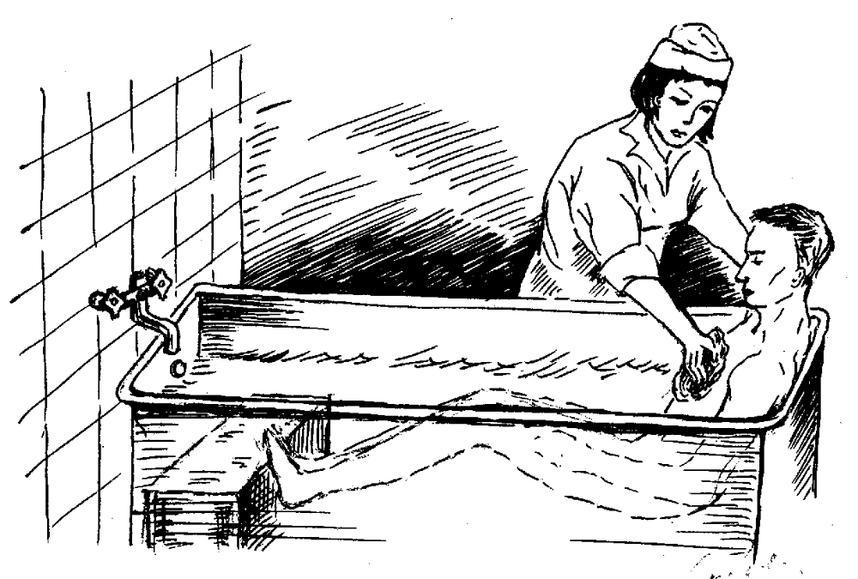
Fig. 1. Position of a patient in a hygienic bath.
3. It is necessary to wash a patient with a bath sponge and soap in the following order: the head, the trunk, arms and legs, the inguinal area and the perineum. Special attention is paid to places of sweat accumulation.
4. The average stay of a patient in a bath is 15-30 minutes, but the time is defined by a patient’s condition.
5. Do not leave a patient in a bath without supervision: watch his appearance and feel his pulse.
A patient can be washed under a shower. This method of sanitization should be preferred, as a patient usually bears a shower better than a bath. Besides being under a shower a patient is washed all the time by pure water.
After a hygienic bath a patient’s nails on hands and feet should be trimmed if it is necessary.
If a patient’s condition is satisfactory, anthropometry (weighing, measurement of height and the chest circle) is carried out. The anthropometry is a complex of ways and methods to measure a human body.
Weighing a patient
Equipment: medical scales.
1. Open the lock of the scales and regulate the scales with a screw: the level of the scales beam on which all weights are in “zero position” should coincide with a control mark.
2. Close the lock and offer a patient to get up cautiously in the center of a platform of scales (without slippers) (fig. 2).

3. Open the lock and move weights on beam lathes to the left until the beam takes the level of the control mark.
4. Close the lock of scales.
5. Write down the results on a temperature chart.
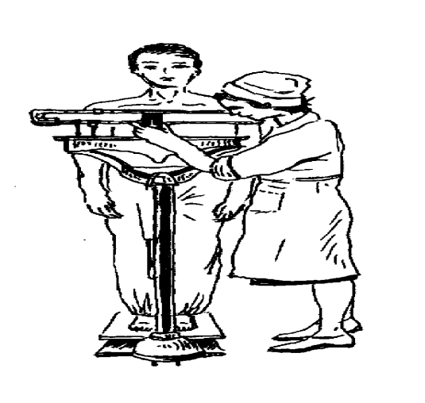
Fig. 2. Weighing a patient.

Weighing a patient is carried out when a patient is admitted to the hospital, weekly and in the discharge from the hospital. Great attention is given to a body weight of patients as during heavy exhausting diseases the increase of body weight is indicative of the improvement of a patient’s condition, while the decrease of body weight in obesity shows the correctness of the appointed treatment. In heart failure the increase of body weight, on the contrary, is a bad symptom (retention of fluid in an organism), and the decrease is a good one (edema decrease).
Weighing should be carried out under certain conditions: in the morning, on an empty stomach, only in underclothes, after intestinal and urinary bladder evacuation.
Measurement of height with the help of height meter :
Equipment: height meter (sometimes combined with medical scales).
1. Stand aside from a height meter and lift a measuring lath from its initial level (it is 100 cm from a platform) up to a level above the prospective height of a patient.
2. Ask a patient to rise on a platform in the following way: his heels, buttocks and scapulae should touch a height meter lath; the head should be in such a position when an ear tragus and an external corner of the eye-socket were on a horizontal line (fig. 3).

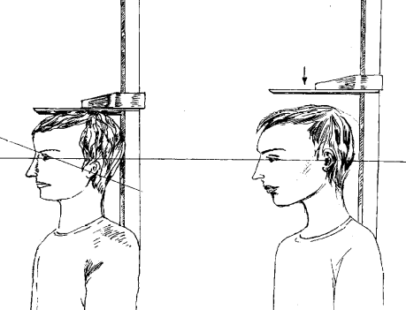
A B
Fig. 3. Wrong (A) and correct (B) positions of the head
in a patient’s height measurement.

Put a height meter lath on the vertex of a patient and define his height on the scale of lath lower edge (fig. 4).
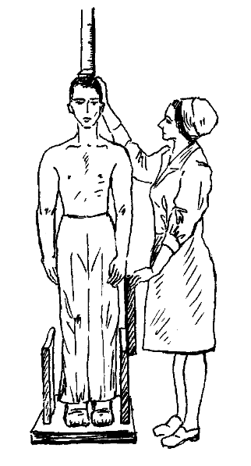
Fig. 4. Measurement of a patient’s height.

Measurement of a chest circle (circumference) :
Equipment: a centimeter tape-measure.
Measurements usually are performed during calm breathing.
1. Apply centimeter tape-measure to a patient so that from behind it passes under the inferior corners of scapulae, and from the front it is at the level of the IV rib (under nipples in men) (fig. 5).
2. Note the results.
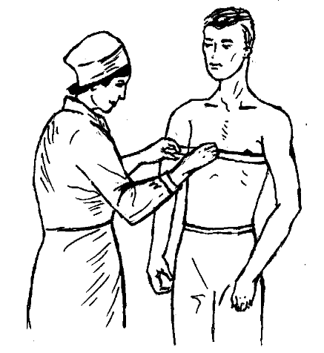
Fig. 5. Measurement of a chest circle.
Transportation of patients to a department
To the department patients are directed on foot, by a wheel-stretcher or a stretcher depending on the health state by the order of a doctor. Means of transportation (wheel-stretcher, a stretcher) are provided with bed sheets and blankets. They should be changed after every use. Patients who move from an emergency department without any assistance go to a ward attended by junior nurses, nurses or hospital attendants.
Transportation of a patient by a wheelchair
Equipment: a wheelchair.
1. Incline a wheelchair forward, stepping on a pedestal for feet.
1. Ask the patient to rise on a pedestal for feet, then supporting a patient seat him into a wheelchair.
2. Put a wheelchair to initial position.
3. During transportation a patient’s hands should not be outside the armrests of a wheelchair (fig. 6).
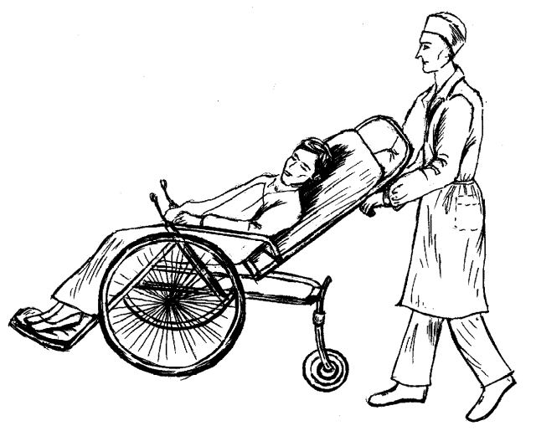

Fig. 6. Transportation of a patient by a wheelchair.

Transportation of a patient by a wheel-stretcher :
Equipment: a wheel-stretcher
1. Put a wheel-stretcher perpendicularly to a couch so that its head part approached the foot part of a couch.
2. Three hospital attendants must stand near a patient on the same side. The first attendant puts his hands under the head and shoulders of a patient, the second one - under the pelvis and the hips, the third one - under the thighs and shins (crura).
3. Lifting a patient, turn together with him for 90° towards a wheel-stretcher side.
4. Lay a patient on a wheel-stretcher and cover him.
5. Inform a department nurse, that a patient is directed to the department (by a wheel-stretcher).
6. At the department: the head part of a wheel-stretcher should be brought to the foot part of a bed, three attendants lift a patient and, turning together with a patient for 90° put him to a bed.

Hand transportation of a patient by a stretcher
Equipment: a stretcher.
1. It is necessary to carry a patient on a stretcher without hurry and shaking.
2. Downstairs a patient should be carried with legs forward, it is necessary to rise the leg part of a stretcher and to lower the head part of it (thus putting a stretcher into a horizontal position) (fig. 7).
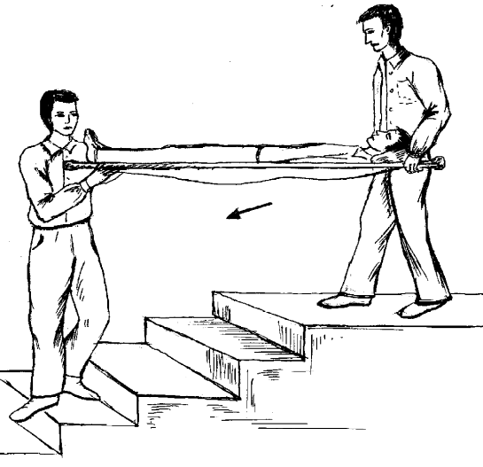

Fig. 7. Transportation of a patient downstairs by a stretcher.
Upstairs a patient should be carried with the head forward in a horizontal position (fig. 8).
Carrying over patients from a stretcher to a bed demands skill and care. Usually it is done by 2-3 hospital attendants. For the convenience a stretcher is put to a bed at the right angle, in parallel, successively, closely. Carrying over a patient when a stretcher is closely put to a bed demands from a patient certain efforts and it is not always allowed.
At the department a charge nurse meets a patient, gets acquainted with him and with his case history, shows him a ward, a lavatory room and other rooms, informs of the regimen at the department. Then a nurse reports on the admitted patient to a doctor and gives a patient’s case history to doctor. Depending on a patient’s condition the doctor examines him immediately or during the round. The doctor makes prescriptions which a nurse is obliged to carry out.
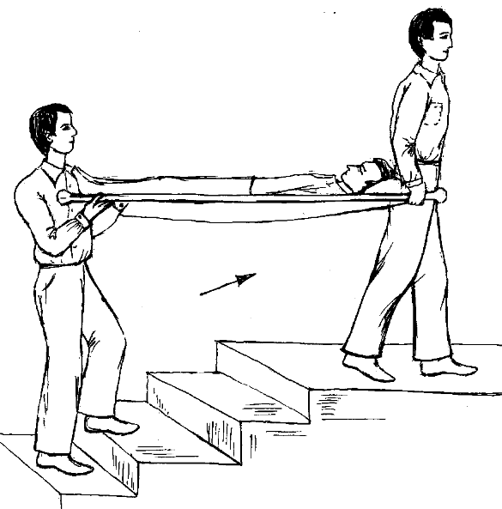
Fig. 8. Transportation of a patient upstairs by a stretcher.

GLOSSARY
Emergency department (emergency room, admitting department) is a part of a hospital where admission, registration, survey, initial examination of patients, sanitization of patients, rendering the qualified medical aid and diagnosis are carried out.
Registration office is a room where registration of patients is carried out.
Room for patient’s examination is a room where the survey and initial examination of patients is carried out.
Sanitary inspection room - a complex of rooms where the sanitization of patients is carried out.
Pediculosis is a disease caused by lice.
Sanitary treatment of patients is the processing carried out in sanitary pass at the emergency department and includes disinsection (destruction of harmful insects), a hygienic bath (or a shower) and changing of the clothes of a patient.
The sanitary-and-epidemiological regimen includes wet cleaning of all rooms, maintenance of cleanliness and order and sanitization of patients.

SITUATIONAL TASKS

Task 1. A patient is delivered to the emergency department. After inspection of his scalp pediculosis was revealed. What must a junior nurse do?
The answer. A junior nurse should treat hair of a patient with soap K, comb it out with a special comb, then make a "P" mark (“pediculоsis”) on the title page of a case history.
Task 2. A patient delivered to a hospital (from an apartment, without being attended), died at the emergency department. What is a nurse obliged to do apart from registration of the documentation?
The answer. A nurse is obliged to give a telephone message to relatives, make the appropriate record in “the Book of the telephone messages”. In case of absence of the telephone in a patient’s flat the information is transferred through a police station in a patient’s residence.
Task 3. A patient with bleeding was delivered to the emergency department. Is it possible for this patient to take a hygienic bath?
The answer. No, it is impossible.
Task 4. A doctor prescribed weighing of a patient. A junior nurse decided to do it after a dinner. Is it correct?
The answer. No it’s not. Weighing should be made in the morning, on an empty stomach.
Task 5. A patient with myocardial infarction was admitted to the emergency department. A junior nurse decided to direct a patient to department on foot, without a doctor’s instruction. Is it correct?
The answer. No, it is not. A doctor should determine a kind of transportation to the department. A patient with myocardial infarction should be transported by a wheelchair or by a stretcher.

CONTROL QUESTIONS
1) What is the emergency department of the hospital intended for?
2) What rooms does the emergency department of the hospital consist of?
3) What are the duties of a junior nurse at the emergency department?
4) What order does the work of the emergency department proceed in?
5) By what ways can the patients be delivered to the emergency department by?
6) What documents should a nurse of the emergency department fill in?
7) What does sanitization include? What are the kinds of sanitary treatment?
8) What rooms does the sanitary inspection of the emergency department of a hospital include?
9) What are the facilities of a room for seeing patients?
10) How is the disinsection made in cases of pediculosis?
11) How the disinsectization of clothes of pediculosis patients is is carried out?
12) What kinds of sanitization are there?
13) What are the contradictions in taking a bath and a shower?
14) How is the patients weighing is carried out?
15) How is the measurement of patient’s height carried out?
16) How is the measurement of the circle carried out?
17) How is the transportation of patients to the department carried out?

Theme. 3
PERSONAL HYGIENE of a PATIENT .
Goal: to get a notion about personal hygiene of the patient. Knowledge objective: - to know rules of care of oral cavity, eyes, ears, nose, ways of prevention of bedsore. Skill objective: - to be able to wash the patient’s perineum, to give a bedpan, to carry out a hygiene of oral cavity, to wash oral cavity (irrigation), to smear the mouth, to take pharyngeal and nasal swabs for bacteriological test, to wash eyes, to drop medications in eyes, to put an ointment on a lower eyelid from a tube and with scoop, to wash external auditory meatus, to drop medicines in ear, to clean nose, to drop medications in a nose.
Subject-matter:
1) care of a skin and prevention of bedsores,
2) use of urinals and bedpans,
3) care of the oral cavity,
4) care of eyes,
5) care of ears and a nose,
6) care of hair.
Equipment required: a lamp - reflector, spatulas, tweezers, glass sticks, droppers, a tray, a flat glass bottle, a rubber circle, gauze napkins, cotton balls, syringes, a metal shaving brush, a test tube, eye ointment, a Jeane syringe, a metal probe, a rubber container, irrigator, a vessel, and bedpans.
Clinical course and outcome in great extent depends on setting where a patient stays. Keeping hygienic standards in the wards, comfortable bed, following personal hygiene, providing of high quality food, balanced diet are necessary for effective treatment.

Care of skin and prevention of bedsore:
The skin carries out some functions:
- protective,
2) analytical (skin sensitivity),
3) regulation of a body temperature (feedback of heat through sweat producing (perspiration) at the healthy person makes 20% of all warm production for day, and at feverish patients - it is much more),
4) secretory.
Through the skin and its sweat glands water, urea, a uric acid, sodium, potassium and other substances are released. At rest at normal body temperature it is released about 1 l of sweat per day, and at feverish patients up to 10 and more.
On a skin at evaporation of sweat there are the products of metabolism that destroy it. Therefore the skin should be clean, so it is necessary to change linen, to wipe skin with eau-de-cologne, water with alcohol (1:1), disinfectant napkins or solutions, for example - 1 glass of water + 1 spoon of vinegar + 1 spoon of camphor alcohol, to wipe skin with a dry clean towel.
Special attention is paid to inguinal area, axillas, at women – under mammary glands. The skin of perineum demands daily washing. Walking patients use bidet for this purpose. Seriously ill patients should be washed underneath after each defecation, and in cases of an incontinence of feces and urine - many times a day in avoidance of maceration and inflammation of skin in inguinal area. Women wash underneath more often.
Bedsore (decubitus) can appear at seriously ill patients– necrosis of the skin with involving hypodermic cellular tissue and other soft tissues. Decubitus ulcers appear more often on sacrum, shoulders, heels, elbows because of long pressure and disturbances of blood circulation in it. First appear redness and tenderness, then epidermis (a superficial layer of skin) husks, bubbles are formed. In case of deep decubitus ulcers muscles, tendons and periosteum are naked. Necrosis and ulcers develop penetrating sometimes up to a bone. The infection penetrates through the injured skin causing suppuration and even sepsis. Appearance of decubitus ulcers is the indication of an insufficient care of the patient!
When a part of skin becomes red it is necessary to wipe it 2 times a day with 10% camphor alcohol, a damp towel, irradiate with a quartz lamp. If decubitus ulcers are formed, it is necessary to grease them of 5 % with a solution of potassium permanganate, to bandage with an ointment of Vishnevsky, or synthomicine liniment etc.
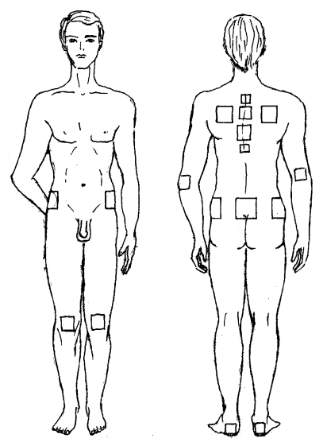
Fig. 12. Places of the most often formation of decubitus ulcers.
Prevention of decubitus ulcers:
1) to change the position of the patient every 1.5-2 hours;
2) to smooth folds on bed and linen;
3) to wipe skin with disinfectant;
4) to change the wet or dirty linen immediately;
5) to use rubber circles placed in a cover or covered with swedding cloth. A circle is enclosed so that the place of ulcer is above an aperture of a circle and did not touch bed. Also special inflatable matresses with a crimped surface;
6) patients should be washed in time.
Usage of bedpans :
For patients on a strict bed regimen, if feces evacuation is necessary, bedpan is submitted in bed, and if it is necessary to empty the urinary bladder - urinals (women at urination usually use a bedpan).
Bedpans are usually metal with an enamel covering or rubber. Rubber bedpan are applied to the impaired patients, and also in case of decubitus ulcers, and in case of an incontinence of feces and urine.
Washing underneath of ill women :
The equipment:
A jug with warm (30-35°С) a light solution of potassium permanganate (antiseptic means) or water, straight packer, a napkin, an oilcloth, a bedpan.
1. To help the patient to lie on the back (legs should be slightly bent in knees and separated).
2. To lay an oilcloth and put a bedpan on it.
3. To stand to the right of the patient and, holding a jug in the left hand, and napkin in right, flow an antiseptic solution on genitals, and make movements with a napkin from genitals to anus, i.e. from the top downward.
4. To drain by a dry napkin the skin of perineum in the same direction.
5. To remove a bedpan and an oilcloth.

Giving a bedpan:
The equipment:
A bedpan, an oilcloth, a screen, disinfectant. If the seriously ill patient wants to have urination or defecation, it is necessary:
1. To put the folding screen from others, to lay an oilcloth under a pelvis of the patient.
2. To rinse a bedpan with warm water, having left some water in it.
3. To bring the left hand sideways under sacrum of the patient, helping the patient to raise a pelvis (the legs are bent in knees).
4. To bring by the right hand a bedpan under buttocks of the patient so the perineum appeared above an aperture of a bedpan.
5. To cover the patient with a blanket and leave him alone for a while.
6. To pour out contents of a bedpan in a lavatory bowl, having rinsed a bedpan with hot water.
7. To wash the patient’s underneath, drain perineum, remove an oilcloth.
8. To disinfect a bedpan with disinfectant.
Care of oral cavity:
Inspection of oral cavity:
The patient opens a mouth. Nurse delays lips and cheeks of the patient with a spatula. At examination of tonsilles and a back wall of pharynx the nurse presses with a spatula on a root of the tongue and offers the patient to make the sound "a". At examination of an oral cavity, tonsilles and pharynx the illumination is necessary for what it is possible to use a lamp - reflector or any other lamp. It is necessary for each person to keep elementary rules of oral cavity hygiene:
- to rinse a mouth with water after each meal;
- to clean teeth before sleeping and in the morning since during the night the surface of a mucous membrane and teeth becomes cover by the soft deposit consisting of epithelium cells, slime and microorganisms.
Formation of a deposit is accelerated in patients, since products of metabolism start to be released through a mucous membrane of the oral cavity: nitrogenous substances if renal insufficiency, sugar if a diabetes, mercury if mercury poisonings etc. These substances pollute a mucous membrane and cause intensive multiply of microorganisms. The care of an oral cavity should be more careful, it’s carried out by nurse at seriously ill patients.

Gargling of the mouth After each meal :
the patient has to gargle his mouth with 0,5 % solution of sodium hydrocarbonate (a solution of baking soda) or 0,9 % solution of sodium chloride (a physiological solution). Then wipe the tongue: it is necessary to impose a sterile gauze napkin on a tip of a tongue, extend it from an oral cavity by the left hand, and by the right hand to remove a coating from a surface of tongue with a cotton balls in tweezers and to grease tongue with glycerin (Washing of oral cavity is carried out with the help of a syringe, a rubber container, irrigator, a rubber tube and a glass tip. Usually light solutions are applied: 0,5 % of sodium a hydrocarbonate, 0,9 % of chloride of sodium, 0,6 % of peroxide of hydrogen, permanganate potassium (1:10000) etc. Set the patient or give him position with a little bit tilted head that the liquid has not got in respiratory ways. Cover the neck and breast with an oilcloth, and substitute a basin or a tray to the chin. If the patient is lying on his back, the head should be turned; if it is possible, also to turn the patient sideways.
Delay a corner of a mouth with spatula and wash out a threshold of his mouth, and then an oral cavity actually in running water. If the seriously ill patient has artificial dentures it is necessary to take them out before procedure, to wash up and to dry. It is not recommended to store artificial dentures in a glass of water, since the microbes on a surface of an artificial dentures are well kept in a dump environment. Smearing of the mouth is administered in diseases of the oral cavity mucous. Boiled spatula, and some sterile cotton balls, tweezers put on a sterile tray. From a bottle pour a small amount of a drug in a flat glass vessel. Ask the patient to open a mouth, take a cotton ball with tweezers, smear it with medication and, helping your self with a spatula, press a cotton ball to the struck place of a mucous membrane, then take a fresh cotton ball, smear with his medicine and put to other place of lesion.

UNIT 2.
DIET AND NUTRITION:
Goal: to get a notion about the principles of dietary menu therapy, to master practical skills.

Knowledge objective:
- to know the basic dietary menu, the principles of the organization of dietary menu therapy in medical establishments, the principles and the organization of artificial feeding of patients;
Skill objectives:
- to be able to choose and prescribe various diets at various diseases,
-to carry out feeding of seriously ill patients;
-to fill nutritious mixtures and solutions through a gastric probe;
-to enter nutritious solutions by means of feeding enema,
-to carry out parenteral introduction of nutrients.
Subject-matter:
1) acquaintance with patients with various diseases, their diet, dietary restrictions;
2) acquaintance with the organization of dietary menu therapy in a hospital;
3) improvement of practical skills of stating a feeding enema, insertion of a gastric probe, assembly of system for intravenous infusion of feeding solutions.
“EDUCATIONAL MATERIAl:
Dietetic therapy is based on I.P.Pavlov's teaching which has proved necessity of due ingestion of food, importance not only of caloric contents of food, but also of its appearance and even personal tastes. The knowledge of basic concepts of dietology, principles of rendering services for patients is very important for a therapist and will be daily used in his professional work.
Dietotherapy – is a treatment with diet of a patient during his disease. An attending physician, a diet specialist and a diet nurse organize the feeding in medical establishments. Feeding of the seriously ill patients is performed through a gastric probe, by means of feeding enemas, parenterally by the intravenous infusion of nutritious solutions. In the Russian Federation the unified dietary system has been preserved till nowadays for maintenance of an individualization of dietary menu therapy to a lot of patients with different diseases and their variable course. It includes medical diets or the dietary menu number 0-15, developed at the Institute of Feeding of the Academy Medical Sciences of the former Soviet Union.
The following parameters are reflected:
1) indications for the use,
2) the purpose of assignment,
3) general characteristics,
4) chemical compounds and caloric content,
5) feeding regimen,
6) the list of products and dishes which are available, allowed or prohibited in a certain order - the products containing fibers, fats, carbohydrates, spices and drinks.

The characteristics of the basic medical diets :
special diet - 0 menu - is administered after intestinal operations up to 2 – 3 days, in the day after operations on lungs, the mediastinum, the heart, and also to a patient who is in a half-conscious condition (impairment of the cerebral circulation, head traumas, fever). This diet is low-caloried, restricted in the amount of fibers, fats, salt (1,5-3,0 g). The food is given in portions, every 2 hours. Liquid and jelly-like food, the skim meat broth, non-sweet fruits and berry kissel, broth of a dogrose, tea with a small amount of sugar are given to the patient. The whole milk is excluded. Eggs, mucous soups, a meat and cottage cheese soufflé are added in 4-5 days. Further a diet extends, minced meals are added.
Diet 1. The principle of a diet consists in the mechanical, thermal and chemical sparing. All food is given in the minced or half liquid form. It is prescribed for acute gastritis with increased gastric secretion, at gastric and duodenal ulcer. The food is prepared on boiled water, by mincing. The caloric value is 2500-3000 kcal. Food is taken 5-6 times a day, and before going to bed - milk, cream or kefir. Vegetable cellular tissue, aerated drinks, kvass, coffee, spices are excluded. Meat, fish, mushrooms, rye bread, coffee, cocoa are limited. Steamed cutlets are recommended.
Diet 1b. The principle of a diet: the restriction of chemical and mechanical irritation of the mucous membrane and receptors of the upper GI tract, stimulators of gastric secretion. It is given in peptic and duodenal ulcer in its acute phase, at symptoms of the irritated stomach. The physiological amount of fibers and fats is preserved, but the carbohydrates and salt are limited. The food is boiled or steamed. Food is liquid, porridge-like. Diet regimen: 5-6 times a day.
Diet 2. The principle of a diet: mechanical sparing, but stimulation of secretion. It is prescribed in the exacerbation of chronic gastritis with the decreased secretion disorder, chronic pricking, after acute infections, in impaired chewing. Food is minced. Very cold dishes 59 are prohibited. Food is taken 5 times a day. Aerated drinks, milk, grape juice, canned food, leguminous, bacon are excluded. Soups and cereals, vegetables on meat and fish broths, baked or boiled vegetables are recommended.
Diet 3. It is given in constipation, hemorrhoids, and cracks of the back passing without an inflammation. Strengthens impellent functions of the bowels. The diet includes vegetables, fruits, berries, bread, cereals, salty and pickled vegetables, vegetable oil, cold drinks and dishes. Patients eat 4-5 times a day. In the morning on an empty stomach they are given cold water with honey or sugar, before going to bed - compotes, prunes, a fig. Coffee, cocoa, strong tea are excluded. It is recommended to take more liquids.
Diet 4. It is prescribed in acute enterocolitis with diarrhea after fasting days, in exacerbation of chronic enteritis, dysentery, after intestinal operations. The diet is given up to 5-8 days, it reduces fermentation and putrefactive processes in the intestines, it is mechanically sparing. Rough cellular tissue, spices, pickles, fresh bread, dough, coffee, cocoa, aerated drinks, cold drinks, grape juice, milk – are excluded. The food is rubbed, boiled.
Diet 4b. It is given in acute diseases of the intestine in the recovery phase; in chronic intestinal diseases post exacerbation or during a slight attack, and sometimes also in the combination for other gastrointestinal tract disorders. Food is taken 5 - 6 times a day. Rough cellular tissue, soups (leguminous, milk, schee, borshch (beetroot soup), rassolnik (soup with pickles); fat, salty and spicy dishes; piquant, fat sauces, mustard, horse-radish, pepper; grapes, plums, apricot juices, fruit-drinks are excluded.
Diet 4c. It is given in acute intestinal diseases during reconvalescence as transition to a balanced diet; in chronic intestinal diseases during the recovery phase, and also in other gastrointestinal tract diseases. The given food is boiled and baked. I is to be taken 5 times a day. Rough cellular tissue; strong fat broths; fat, salty, spicy dishes; dairy products with high acidity; fried eggs; leguminous porridges; garden radish, radish, onions, garlic, cucumbers, swede, turnip, spinach, mushrooms; spicy and fatty snacks, smoked products, canned food; spicy and fat sauces, mustard, horse-radish, pepper; grapes, plum, apricot juices – are excluded.
Diet 5. It is used in chronic hepatitis, viral hepatitis in a recovery stage, in chronic cholecystitis. Fats are limited. Mushrooms, coffee, cocoa are excluded.
Diet 5а. It is used in acute hepatitis, exacerbations of chronic hepatitis, liver cirrhoses, acute cholecystitis, in acute pancreatitis. Fats, exclude products rich in cholesterol, rough cellular tissue, fried dishes should be limited or excluded. The food is taken 5-6 times a day. Coffee, aerated drinks, vegetables, greens, garlic, onions, garden radish, radish, leguminous are excluded.
Diet 5b. It is used in chronic pancreatitis during the recovery phase after the relapse and in remission. A diet is rich in fiber, low in fats and carbohydrates, particularly in sugar. Extractive substances, purines, refractory fats, cholesterol, radio oils, rough cellular tissue are limited, fried dishes are excluded. The amount of vitamins and lipotropic substances is increased. All food is recommended in the rubbed and crushed state, cooked in boiled water or baked. Hot and very cold dishes are excluded. Meals are taken 5 - 6 times a day. Before going to bed kefir is given. Rough cellular tissue; meat soups, fish broth, mushroom and vegetables broths, with millet, dairy soups, beetroot soups, cabbage soups; fat, salty and spicy dishes; dairy products rich in fat and sugar; dishes with hard-boiled and fried whole eggs; all spices; coffee, cocoa, aerated and cold drinks, grapes juice are excluded.
Diet 6. It is used in renal calculus disease with uric and oxalic acid calculi, in gout. The products containing oxalic acid, purines are excluded. Fats, fibers are limited, in obesity carbohydrates are restricted. Liquids are given in the amount of 2-2,5 l (alkaline mineral waters), food is taken 4-5 times a day. Coffee, cocoa, strong tea – are excluded.
Diet 7. It is prescribed for the recovery phase in acute nephritis and remission of chronic nephritis, nephropathy in the pregnant. All foods are taken without salt. Fish, mushrooms, cocoa, coffee are excluded. Liquid is limited up to 1 l a day. Food is taken 5-6 times a day.
Diet 7а. It is used up to 5-6 days in acute nephritis and in chronic nephritis with chronic renal failure. It is a vegetarian food with limitation of fibers and salt exclusion. Caloric content is reduced up to 2000-2400 kcal, the contents of vitamins is increased. The amount of taken liquid should be calculated according to the urine excretion during 61 the previous days. Food is taken 5-6 times a day. Coffee, cocoa, strong tea are excluded.
Diet 7b. It is used in the same diseases, as in the menu No 7а, but on the 6-7-th day boiled meat and fish are added. The amount of salt is 2-3 g per day.
Diet 7c. It is used in the nephritic syndrome. Liquids, sodium chloride, extractive substances, cholesterol, the oxalic acid are significantly limited, sugar is limited as well, and the amount of lypotropic substances is increased. Cooking is done without mechanical sparing. Meat and fish are boiled. Food is prepared without salt. The feeding regimen is 5 - 6 times a day. Before going to bed kefir is given.
Diet 7d. It is prescribed in a terminal (final) stage of the renal failure, in hemodialysis, i.e. purification of blood of a patient with the help of “an artificial kidney“. The purpose is a provision of the balanced feeding in case of the severe renal failure and side effects after hemodialysis. Food is prepared without salt, bread is saltless. In case of absence of arterial hypertension and hypostases a patient is given 2–3 g of sodium chloride. Products containing potassium are limited. A sufficient amount of irreplaceable amino acids is provided with meat, fish, eggs and dairy products. Cooking is done without mechanical sparing; meat and fish are boiled. The taste of dishes is improved with sauces, spices, citric acid. Temperature of dishes is usual. Food is taken 6 times a day.
Diet 8. It is used in obesity. The amount of carbohydrates, fats (especially animals’ fats) is reduced, and the amount of fibers is increased. Liquid, salt, the dishes that raise the appetite are limited. Salt is given in the amount of 5 g a day. Food is taken 5-6 times a day. Such drinks as tea, coffee, juices, except grapes are allowed. Lemonade, flavouring condiments are excluded. There must be special days of the limited intake of food (apple, dairy, cottage cheese, meat, vegetable, etc.).
Diet 9. It is used in diabetes. Carbohydrates and fats are moderately reduced, fibers are increased. Sugar, sweets (they are replaced with xylitol, sorbite), grape juice, lemonade are excluded. The use of vitamins is increased.
Diet 10. It is given in cardiovascular diseases without signs of heart failure. Fats, salt (up to 5 g a day), the amount of liquids (up to 1 l a day) are limited. Food is taken 5-6 times a day. Fat dishes, salty snack, alcohol, chocolate, beans are excluded.
Diet 10а. It is used for the limited time (no more than 4 weeks) in cardiovascular diseases with clinically obvious heart failure. Salt and liquids are significantly limited. Food is prepared without salt. Fat dishes, spicy and salty dishes, coffee are excluded.
Diet 10c. It is used in atherosclerosis of the arteries with the primary coronary arteries disease, cerebro-vascular disease, myocardial infarction in a stage of scarring, arterial hypertension. The purpose is to prevent the progression of atherosclerosis, decrease body mass in obesity. The products that are rich in cholesterol and vitamin D are excluded. But the products having lipotropic action; vegetable oil with high content of polynonsaturated fat acids; vegetables, fruits and berries as natural sources of vitamin C, besides they contain vegetative cellular tissue; sea products that are rich in iodine – are all included into the diet. Salt is limited as well as free liquid up to 1000-1200 ml. Food is taken 5-6 times a day in the moderate quantity, supper is taken 3 h before going to bed.
Diet 11. It is used in pulmonary tuberculosis, anemia, in exhaustion. The amount of fats is in full volume. The use of fibers, carbohydrates, vitamins, calcium and iron is increased. Caloric content is 3300-6800 kcal. The food is taken 5 times a day. Fat meat, poultry, spicy sauces, cakes with plenty of cream are excluded.
Diet 12. It is used in diseases of the central nervous system accompanied by the increased nervous excitability; in a transition period from the 10-th diet a balanced diet. Salt is limited, the quantity of vitamins is increased. The dishes causing superfluous gas production are excluded. Food is taken 5-6 times a day.
Diet 13. It is used in acute infectious diseases in the febrile period. The amount of fats and fibers in a diet is limited, the caloric content is reduced, and the use of vitamins and liquid is increased. Rough cellular tissue, salty, fat, spicy dishes and spices are limited. Such drinks as fruit and berry juices, broth of a dogrose, morses, tea with lemon are allowed. Food is taken 8 times a day, by small portions.
Diet 14. It is used in a kidney-calculus disease and pyelocystitis with the urinal alkaline reaction, in phosphaturias. Vegetables like potatoes, carrots, cabbage, berries are limited, the amount of fats is 63 increased up to 120 g a day. The amount of liquid is 2-2,5 l per day, salt - 12-15 g per day. The food is taken 4-5 times a day. Dairy products, salads, canned food, fruit and berry juices – are excluded.
Diet 15 (a common table). Indications: all diseases in the absence of the prescribed special diet, it is given to patients without signs of failure of gastrointestinal tract organs. A diet is physiological, contains double quantity of vitamins and doesn’t include fat meat. Salt is given 12-15 g per day.
Unloading (fasting) diets:
In cardiovascular, gastrointestinal, renal diseases, on a basis of the main medical diet 1-2 times a week for 1-2 days fasting diets are appointed. The purpose is to limit the intake of food, to facilitate the functions of the organs and the systems to promote the discharge from an organism of products of the disordered metabolism. The prevalent food components in the unloading diets are subdivided into protein (dairy, cottage cheese, meat - vegetable), carbohydrates (fruit, sugarvegetable), fatty (cream, sour cream), combined (consisting of various products) diets.
Dairy diet. It is used in cardiovascular diseases, heart failure, arterial hypertension, obesity, liver and gall bladder diseases, pyelitis and pyelocystitis. In this diet milk, kefir or curds in the amount of 200- 250 ml is given every 2,0 - 2,5 hours 6 times a day (in the total of 1,2- 1,5 l). The famous diet of Karell is well known. This diet was offered in 1865 by the doctor Karell and was used in a complex treatment of cardiac and renal diseases with the help of skim milk (0,8-3 l a day) with confinement to bed. According to the classical variant of this diet, during the first week a patient is given 200 ml of skim milk 4 times a day; later dried bread crumbs are added with the following use of the ordinary mixed food. Nowadays different modifications of the Karell diet are used. They are used with different additives to a daily ration (e.g. an egg, saltless bread, fruit juice, etc.).
Cottage cheese diet. It is used in severe heart failure, chronic nephritis with edema, but without azotemia, in obesity. It consists of 500 g of cottage cheeses and 150 g of sugar, 1-2 glasses of broth of a dogrose. It is given in 5 equal parts in 2-2,5 hours five times a day.
Apple diet. It is used in obesity, arterial hypertension disease, cardiosclerosis, chronic nephritis, chronic pancreatitis. Apples are taken 5 times a day by 250-300 g of ripe crude apples (1,25-1,5 kg in the total). In chronic enterocolitis with diarrhea - 5 times a day by 250-300 g of crude grated apples peel- and seeds-free are given. Caloric content of a diet us 500 - 600 kcal.
Compote diet. Indications are the same as for Apple diet. 6 times a day one glass of the compote cooked from 200 g of dried fruit, 60-70 g some sugar with 1,5 l of water is given. Caloric content - 750 kcal.
Dairy-potatoes diet. It is given in chronic nephritis with edema and azotemia, heart failure, diseases with acidosis. It is prescribed up to 2-6 days. 1 kg of potatoes, 0,5 l of milk are included. Salt is excluded. Caloric content - 1200-1300 kcal.
Raisins diet. Indications are the same as for diary-potatoes diet. It is prescribed for one day and consists of 0,5 kg of seedless raisin. It is given 5-6 times a day with equal portions.
Tea diet. It is recommended in gastritis with secretory insufficiency, enterocolitis. It is given up to 1-2 days. 7 glasses of sweet tea with 10-15 g sugar on a glass are given per day.
Meat and vegetable diet. It is given in obesity. It consists of 350 g of cooked beef, 0,6 kg of vegetables (cabbage, cucumbers, carrots). The food is taken 6 times a day.
Water-melon diet. It is used in nephritis, gout, kidney-stone disease with uraturia. Give 300 g of water-melon 5 times a day.

Feeding of patients
Depending on a way of reception of food by a patient there are following forms of a feeding:
1) an active feeding (the patient eats independently),
2) a passive feeding (the patient accepts food with the help of a nurse),
3) artificial feeding (feeding of the patient by special nutritious mixtures through a tube or a probe (gastric or intestinal) or by intravenous infusion - parenteral feeding, or by nourishing enema).
Passive feeding
At the strict bed regimen, weak and seriously ill patients, patients of elderly and senile age and also in case of necessity, are fed by spoon by the medical nurses. At passive feeding it is necessary to elevate a head of the patient with a pillow by one hand, and by another - to bring to his mouth a feeding-cup with liquid food or a spoon with meal. It is necessary to feed with small portions of food, leaving the patient time on chewing and swallowing; liquids are given with the help of feeding-cup or from a glass by a special tubule.
The Order of the performance of procedure:
1. To air a room.
2. To clean the patient’s hands (to wash up or wipe with a damp, warm towel), to put a clean napkin on a neck and a breast of the patient.
3. To place dishes with warm meal on a bedside-table, to sit a patient comfortably (sitting or half -sitting). At a strict bed regimen it is necessary to raise by one hand a head of the patient with a pillow, and by another - to bring to his mouth a feeding-cup with liquid food or a spoon with meal.
4. It is necessary to feed the patient with small portions of food, leaving time on chewing and swallowing.
5. To give liquids with the help of a feeding-cup or from a glass by a special tubule.
6. To remove dishes, a napkin (an apron), to help the patient to rinse a mouth, to wash up (to wipe) his hands, to lay the patient in a starting position.
Artificial feeding
Artificial feeding usually means feeding of the patient enterally (from Greek entera - intestines), i.e. by gastrointestinal tract, and parenterally (from Greek. para - near + entera - intestines) – without gastrointestinal tract inclusion.

Enteral feeding

Enteral feeding is a kind of nutrition therapy used when it is impossible to provide an adequate maintenance of power and plastic needs of the organism in the natural way. Thus nutrients are entered through a mouth or through gastric tube. Not long ago rectal way of introduction of nutrients was used - rectal feeding (introduction of food through a rectum). In modern medicine such type of feeding is not used as it is proven, that fats and amino-acids are not taken by rectum. However in some cases (for example, dehydration due to vomiting) introduction of a so-called physiological solution (0,9% sodium chloride solution), glucose and other substances is possible. Such method is called “medical (nutritious) enema”.
The organization of enteral feeding in treatment-and-prophylactic institutions is carried out by a team of nutritious therapy (Latin “nutricium”- a feed) including doctors-anesthesiologists - reanimators, gastroenterologists, physicians and surgeons, who had special training on enteral feeding.
The main indications: tumours, especially in the region of head, neck and stomach; deterioration of the central nervous system, comas, impairment of cerebral circulation; radio- and chemotherapy; gastrointestinal tract diseases - chronic pancreatitis, ulcer active colitis, etc.; diseases of a liver and bilious ways; a feeding in pre- and the postoperative states; trauma, burns, acute poisonings; infectious diseases (botulism, tetanus etc.); mental disorders - psychological absence of appetite, severe depression, etc.
The main contra-indications: intestinal impassability, acute pancreatitis, severe forms of malabsorbtion (Latin “malus” - bad, “absorption” - absorption: impairment of digestion of one or several nutrients in a small bowl), gastrointestinal bleeding; shock; anuria (at absence of immediate replacement of kidney’s functions); presence of a food allergy on components of the prescribed nutritious mixture; severe vomiting.
Depending on duration of enteral feeding and preservance of function of various parts of gastrointestinal tract there are following ways of introduction of nutritious mixtures:

1. The use of nutritious mixtures drinks through a tube by small portions.
2. Feeding with the help of nasogastral, nasoduodenal, nasojejunal and two-channel probes (for aspiration of gastroenteric contents and intraintestinal delivery of nutritious mixtures, mainly for surgical patients).
3. By installing of stomas (Greek “stoma” - an aperture: the external fistula created by operative way): gastrostomas (an aperture in a stomach), duodenostomas (an aperture in a duodenal gut), jejunostomas (an aperture in a lean gut). Stomach can be installed by surgical laparotomy or by endoscopy.
There are some ways of enteral delivery of nutrients:
1) by separate portions (fractionally) according to the prescribed diet (for example, 8 times a day by 50 ml; 4 times per day by 300 ml);
2) by slow prolonged infusion;
3) automatically adjusting food delivery with the help of special dozator.

For enteral feeding liquid food (a broth, mors, a dairy mix), mineral water, homogenous dietary canned food (meat, vegetable) and the mixtures balanced according the contents of fibers, fats, carbohydrates, mineral salts and vitamins are used.
The nutritious mixtures used for enteral feeding
1-The mixtures providing early restoration of small bowel function on provision of homeostasis and maintenance of water-electrolyte balance of an organism: "Citroglucosolan”, "Gаstrоlit", "Orasan", "Rehidron".

2. “Element chemically exact” nutritious mixtures for feeding of patients with the marked impairment of digestive function and obvious metabolic disorder (liver and renal failure, a diabetes mellitus, etc.): “Vivonex”, “Тravasorb”, “Hepatic Aid” (with the high contents of the so-called ramified amino acids - valyne, leycine, isoleycine), etc.
3. “Half-elemented balanced” nutritious mixtures (as a rule, they also include a full set of vitamins, macroelements and trace elements for feeding the patients with digestive dysfunctions): “Nutrilon Pepti”, “Reabilan”, “Peptamen” etc.

4. The polymeric well balanced nutritious mixtures (artificially created nutritious mixtures containing optimum proportions of all basic nutrients): dry nutritious mixtures “Ovolact”, “Unipit”, “Nutrison” etc.; liquid, nutritious mixtures ready to the use “Nutrison Standart”, “Nutrison Energy” etc.

5. Modular nutritious mixtures (a concentrate of one or several macroelements and trace elements) with the purpose of enrichment of a daily diet of the person: “Albuminous Aenpit”, “Phortogen”, “Diet-15”, “Аtlanten”, “Peptamin”, etc. Distinguish protein, power and vitamin-mineral modular mixtures. These mixtures are not used as isolated enteral feeding of patients because they are not balanced.
The choice of mixtures for adequate enteral feeding depends on character and severity of disease, and also on preserved functions of a GI tract. So, at normal requirements and preservance of functions of a gastrointestinal tract there are prescribed standard nutritious mixtures, at critical and immunodeficiency conditions - nutritious mixtures with high contents of biologically active fiber, enriched with trace elements, glutamine, arginine and omega-3 fatty acids, at renal failure - nutritious mixtures with the contents biologically high valuable fiber and amino acids. At nonfunctioning intestines (intestinal obstruction, severe forms of malabsorbtion) parenteral feeding is used.

Parenteral feeding

A parenteral feeding is carried out by intravenous infusion of preparations. The main indications: a mechanical obstruction of passage of food on different level of GI tract (tumor, burns, postoperative stricture); preoperative preparation of patients for large operations, the exhausted patients; postoperative patients (after operations on GI tract); burns; sepsis; gross blood loss; impairment of digestion in GI tract (cholera, dysentery, enterocolitis, disease of operated stomach and so forth), non stopping vomiting; anorexia and denial of food.
For parenteral feeding the following kinds of nutritious solutions are used: fibers (albuminous hydrolisates solutions of amino acids: Vamin, Aminosol, Aminosterill, Polyamin etc.), fats (fatty mixes: Lipofundin,Intralipid, etc.), carbohydrates (10% glucose solution, as a rule, with addition of microcells and vitamins), donor blood, plasma, plasma substitutes.

There are 3 basic kinds of parenteral feeding:
1. Full (all nutrients are entered through a vascular access; the patient does not drink even water).
2. Partial (incomplete) - the basic nutrients (for example, fibers and carbohydrates) are used only.
3. Auxiliary - feeding through a mouth insufficient and in addition introduction of some nutrients is required additionally.
The high dozes of a hypertonic solution of glucose (10% solution) irritate peripheral veins and can cause their inflammation (phlebitises), therefore they are delivered only through the central veins (subclavicular vein) or through permanent catheter which is placed with careful aseptic and antiseptic precautions (see chapter “Ways of application of medical products”).
CONTROL QUESTIONS
1. Importance of a diet in the treatment of a patient.
2. Daily need (requirement) of a healthy person in nutrients.
3. The organization of feeding in medical establishments.
4. Ways of patient’s feeding.
5. The basic dietary menu, its main characteristics.
6. Concept about the days limiting the intake of food (contrast diets).

UNIT 3
Theme 1. Body temperature, temperature taking and nursing the feverish patients.

Goal: to get a notion about the device of thermometers, the rules of their storage, disinfection and temperature taking, types of fever, ways of feverish patients’ care; to master skills. Knowledge objectives:
- to know the fever’s definition, its stages; temperature taking rules; mistakes in temperature taking; classifications of fever. Skills objectives:
- to develop practical skills in temperature taking and registration on a temperature chart; care of feverish patients in different stages of fever.
Subject-matter:
1) the device of thermometers,
2) the rules of thermometers storage and disinfection,
3) the rules of temperature taking,
4) the types of fever,
5) the ways of feverish patients’ care.
Equipment required:
the maximal medical thermometer, the marked glass (jar) for disinfection of thermometers with 2% and 0,5% chloramine solution, a temperature chart.
The mankind has three main enemies at any rate: Fever, Starvation and War. It is Fever that one dreads most among them”. Sir William Osler, 1896 Fever is the rise of body temperature that appears as protectiveadaptive reaction of the organism in response to pathogens, is a nonspecific attribute of many diseases. Fevers are divided by a level of the temperature rising and by character of fluctuations of a body temperature. There are rules of temperature taking which allow avoiding mistakes. The temperature must be registered on the temperature chart. Signs of illness are specific and non-specific. The rise of body temperature higher than 37°С is a non-specific sign of illness. Fahrenheit in 1723 was the first who offered to take temperature by means of medical thermometer.
Disturbances of thermoregulations, connected with change of a metabolism (accumulation of so-called pyrogenic substances - products of disintegration of fibers etc.) are the main reasons of the temperature rising. The maintenance of higher, than normal, temperature could be considered as the reaction to various irritators which leads to a thermoregulation reorganization. More often fever arises in infectious diseases, but the temperature rising can be only of the neurotic origin.
The medical maximal thermometer which has graduation from 34 up to 42 degrees on Celsius (°С) is used for temperature taking. It can be graduated also on Fahrenheit( Fig. 1) . The thermometer is called “maximal” because after temperature taking it continues to show that maximal temperature which has been found out in a person at measurement since mercury independently can not be lowered in the tank of the thermometer without its additional shaking. One can choose from several types of thermometers. Today most thermometers have digital readouts.
Some thermometers take temperature quickly from the ear canal and can be especially useful for young children and the elderly. Others can be used rectally, orally or in an armpit. If a digital thermometer is used, read the instructions to know what the beeps mean and when to read the thermometer. Under normal circumstances, temperature tend to be highest around 4 p.m. and lowest around 4 a.m. (Fig. 2).
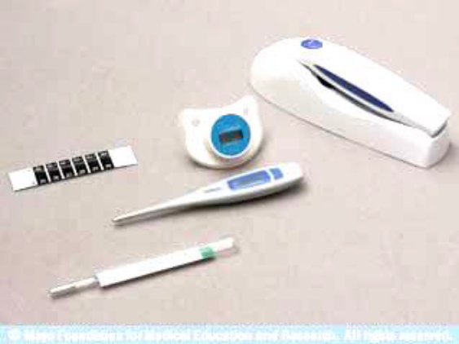
Fig. 2. Types of thermometers.
Fever has three stages (periods) - the temperature rising, top of temperature (constant high temperature) and temperature falling. These stages in "classical" variant are submitted at the so-called continued fever which happens in pneumonia.
Principles of care of feverish patients depending on a stage of fever can be formulated as follows:
- in the first period of fever it is necessary "to warm" a patient,
- in the second period of fever it is necessary "to cool" a patient,
- in the third period of fever it is necessary to prevent falling of blood pressure, haemodynamic disturbances.

Rules of temperature taking:
Thermometers are stored in a glass (jar) with a disinfectant solution (0,5% chloramine solution), a layer of cotton wool at the bottom of a glass. Before temperature taking it is necessary to take out the thermometer from disinfectant to dry it and to shake. The basic
The temperature rising on 1°С is accompanied by increasing of frequency of respiratory movements (FRM) by 4 breaths and increasing of pulse by 8-10 beats per minute in adults and up to 20 beats per minute in children.
Mistakes in temperature taking:
1. A nurse didn’t shake up the thermometer.
2. The hot-water bottle is put to the arm on which the temperature is measured.
3. Temperature taking in severely ill patients (bad pressing of the thermometer by a patient).
4. The tank with mercury was outside of axillary area.
5. Simulation of the temperature rising by a patient.

Temperature registration in a temperature chart :
A patient’s name, date and time (morning and evening) of temperature taking are fixed in the temperature chart. The results of temperature taking are marked with points. In connection of points with each other the temperature curves appear, they are analyzed by a doctor. In a healthy person the temperature can change from 36 to 37°С, in the morning it is usually lower, and it can be higher in the evening. Usual physiological fluctuations of temperature within a day are 0,3- 0,5°С. Age characteristic features of temperature: it is higher in 9 children; in the elderly and exhausted patients decrease of temperature is marked, and even severe inflammatory disease (for example, pneumonia) can proceed with normal temperature. On a temperature chart on the ordinates axis (vertically) values of the body temperature are marked (the scale “Т°”, every division is 0,2°С). On the abscissa axis (horizontally) the days are marked with the division into morning (“m.”) and evening (“evg.”) columns. Body temperature is marked by points (dark blue or black colour) which are connected by the direct lines. Thus the temperature curve is done. Its type has diagnostic value in many diseases. Besides graphic registration of temperature, the curve of the pulse rate is built (the scale "P", red colour) and blood pressure is marked (the scale "BP"). Daily FRM, body weight (every 7-10 days), diurnal amount of consumed and urinal excretion (in millilitres) are expressed in figures on a temperature chart.
Classifications of fever:
Fever is characterised according to the degree of temperature rise (by M.V.Chernorutsky):
1) subfebrile - temperature 37-38°С (it is usually connected with the keeping heat as a result of decrease of heat emission irrespective of presence or absence of the latent inflammatory foci);
2) moderate (febrile) - gradually, within several days: in typhus fever - for 2-3 days, in typhoid fever - for 3-6 days. 2. Remittant fever. Long fever with the daily fluctuations of temperature exceeding 1°С (up to 2°С), without fall to the normal level. It is characteristic of many infections, local pneumonias, pleuritis, and purulent diseases.
3. Hectic, or exhausting, fever-Daily fluctuations of temperature are significant - 3-5°С - with temperature fall to normal or subnormal figures. These fluctuations of temperature can occur two or three times a day. It is characteristic of sepsis, abscess (of lungs and other organs), milliar tuberculosis.
4. Intermittent, or alternating, fever- The temperature raises quickly up to 39-40°С and within several hours quickly decreases up to normal. In 1 or 3 days the temperature rise repeats. Thus more or less regular change of high and normal temperature occurs within several days. It is characteristic of malaria, the Mediterranean fever (periodic illness).
5. Recurrent (relapsing) fever-Opposite to the alternating fever, quickly elevated temperature is kept at this level within several days, and then temporarily falls down up to normal one with the subsequent new increase, and it occurs repeatedly. It is characteristic of recurrent typhus.
6. Perverted fever-In such fever the morning temperature is higher than that in the evening. It is characteristic of tuberculosis.
7. Wrong fever- Fever of uncertain duration with irregular and various daily fluctuations. It is characteristic of the flu, rheumatism.
8. Undulant fever-Change of the periods of gradual temperature increase (for some days) and gradual temperature decrease is marked. It is characteristic of brucellosis (abortus fever).
Rules of care of feverish patients.
The I period of fever(fig.3) . In sudden temperature rise a patient suffers from chill, pains in the whole body, headache, he can not get warm.
A nurse should:
1. To calm and put a patient to bed, put a hot-water bottle to feet, cover a patient with a blanket, give fresh tea.
2. To supervise activities of daily living.
3. Not to leave a patient alone.
4. To eliminate draughts..
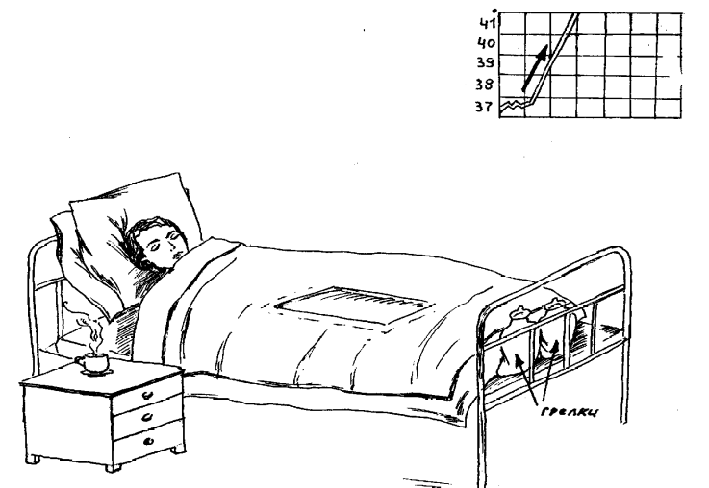
Fig. 3. The I period of fever.

The II period of fever(Fig. 4) .In continued high temperature a patient can be disturbed by high fever, the so-called irritative disorders of consciousness due to the expressed excitation of the central nervous system, manifestation of intoxication delirium (unreal sensation, hallucinations, psychomotor excitation (delirium), tossing and turning in bed.

A nurse should:
1. To organize an individual care.
2. To remove a blanket, to cover a patient with bedsheets.
3. To air a room avoiding draughts.
4. To control haemodynamic indices.
5. It is possible to put on or hang above the patient’s head an icebag or lotions (i.e. a towel folded four times or linen cloth moistened in a solution of vinegar half-and-half with water and swinged for 5-10 minutes). It should be changed regularly.
6. To look after the oral cavity, the nose and other organs, help in patient’s activities of daily living, to prevent bedsore.
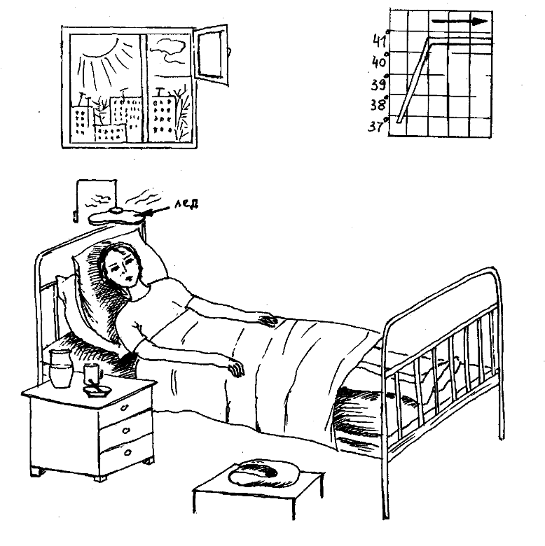
Fig. 4. The II period of fever.

The III period of fever (fig. 5). Temperature decrease can be gradual (lytic) or fast (critical). Critical temperature decrease is accompanied by excessive sweating, general weakness, pallor of skin and collapse (sharp vascular insufficiency) can develop. Blood pressure falling is a major diagnostic sign of collapse. Maximal (systolic), minimal (diastolic) and pulse pressure is reduced. It is possible to speak about collapse in the decrease of maximal BP up to 80 mm of Hg. Progressing decrease of systolic BP testifies the collapse gravity.
A nurse should:
1. To inform a doctor urgently about a patient’s condition.
2. Not to leave a patient alone.
3. To remove rapidly a pillow, raise a foot part of a functional bed on 20 to give a patient the horizontal position with the raised legs.
4. To put on the arms and feet hot-water bottles in a towel.
5. To use oxygen humidified with water.
6. To change linen and bed-clothes, to sponge skin with dry napkins.
7. To control haemodynamic indices.

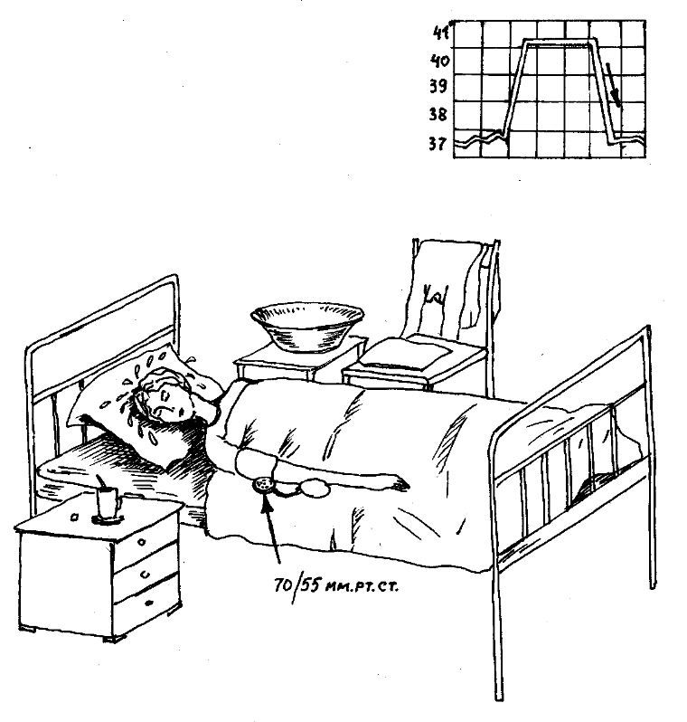

Fig. 5. The III period of fever.

PRACTICAL SKILLS

Temperature taking in an armpit :
Equipment: the maximal medical thermometer, a glass (a jar, a vessel) with a disinfectant solution (3% chloramine solution), an individual napkin, a temperature chart.
1. To examine an armpit, to sponge it with a dry napkin.
2. To take a thermometer from a glass. In cases of skin allergic reactions at contact with chloramine solution, after disinfection it is necessary to rinse a thermometer under running water and sponge it dry.
3. To shake a thermometer for decrease of mercury column to a mark below 35° С.
4. To put a thermometer into an armpit so that the mercury tank from all sides touches a patient’s body.
5. To fix a patient’s arm or to ask a patient to keep a thermometer in fixed position by pressing of the bent arm.
6. To keep a thermometer for 10 minutes.
7. To take a thermometer out and remember the received results.
8. To shake mercury in a thermometer to a mark lower than 35°С.
9. To place a thermometer in a vessel with a disinfectant solution.
10. To register the result in a temperature chart.
Temperature taking in the rectum

Equipment: the maximal medical thermometer, a glass (a jar, a vessel) with a disinfectant solution (3% chloramine solution), Vaseline, medical gloves, a temperature chart.
1. To put a patient on his side with legs pressed to the stomach.
2. To put on rubber gloves.
3. To take a thermometer out of a glass with a disinfectant and wipe it dry.
4. To shake a thermometer to lower mercury column lower than 35°С.
5. To oil a thermometer mercury end with vaseline.
6. To introduce a thermometer into the anus to the depth of 2-4 cm and carefully press the buttocks. Buttocks should tightly touch one another.
7. To keep a thermometer for 5 minutes.
8. To take a thermometer out and remember the received result.
9. To wash carefully a thermometer in warm water and place it in a glass with disinfectant solution.
10. To shake a thermometer up to a mark lower than 35°С.
11. To disinfect a thermometer and gloves.
12. To fix the indices in a temperature chart with the indication of a place of taking.
Temperature taking in the inguinal bent (in children)
Equipment: maximal medical thermometer, jar with a disinfectant solution (3% chloramine solution), an individual napkin, a temperature chart.
1. In order to prevent skin allergic reactions in contact with chloramine solution after disinfection it is necessary to rinse a thermometer under running water.
2. To wipe a thermometer dry and shake it for the decrease of a mercury column below 35°С.
3. To bend a child’s leg in coxofemoral joint so that a thermometer occurs in the formed skin bend.
4. To keep a thermometer for 5 minutes.
5. To take a thermometer out and remember the received data.
6. To shake a thermometer to a mark lower than 35°С.
7. To place a thermometer into a jar with disinfectant solution.
6. To register the result in a temperature chart with the indication of a place of taking.
Oral temperature taking:
1. To place the bulb under a patient’s tongue.
2. To ask a patient to close the mouth for three minutes approximately.
3. In using a nondigital thermometer, rotate it slowly after removing it from the mouth until you can read the temperature.

CONTROL THEMES FOR DISCUSSION :
1. Fever’s definition.
2. The fever’s periods.
3. Rules of temperature taking.
4. Mistakes in temperature taking.
5. Types of fevers.
6. Care of feverish patients in the I period of fever.
7. Care of feverish patients in the II period of fever.
8. Care of feverish patients in the III period of fever.

UNIT 4:
Theme 1: NURSING THE PATIENTS WITH RESPIRATORY DISEASES :
Goals of the class: to get a notion about the main pathological symptoms and methods of the first premedical aid in the respiratory diseases; to master skills. Objective of the class:
- to know the basis of human physiology of the respiratory system, the main symptoms of respiratory diseases and pathogenesis of their origin, rules of sputum collection, care pecularities of patients with respiratory diseases, rules of pleurocentesis performance;
- to master the methods of observation of respiration, oxygenotherapy and safety measures working with oxygen, first premedical aid for patients with the symptoms of respiratory diseases.
The subject-matter of the class:
1) human physiology of the respiratory system, types of breathing in the norm;
2) the main symptoms of the respiratory diseases and the fundamentals of the general care of patients in their development.

Equipment required:
tables, stopwatches, oxygen pillows, nosal catheters, spittoons with a lid, Petri dishes, ice bags, gauze napkins, 10 ml - syringes with thick pleurocentesal needle, pocket inhaler, test tubes. Place: a study room, a ward, an intensive care ward.
Process of gas exchange consists of external and internal (tissue) respiration. External breathing is a gas exchange between atmospheric and pulmonary air and between pulmonary air and blood. Basically gas exchange takes place in the alveoli. Gas exchange is insignificantly (1-2%) performed through skin and digestive tract. Pulmonary ventilation is realized due to inhalation and exhalation – movements of the chest. A number of respiratory movements in a healthy man varies from 16 to 20 per minute. Respiration rate depends on age, sex and body position. Accelerated respiration occurs on physical exertion, nervous excitement, body temperature rise. Breathing slows down in sleep and in horizontal position. Counting of respiratory movements is performed invisibly to a patient. For this purpose a patient’s hand is taken (as if to feel pulse rate) and placed to a patient’s chest, but in reality it is done to count thoracic respiratory motions. Normally respiration is rhythmical and of medium depth.
There are three distinctive physiological types of breathing:
1. Thoracic type – breathing is basically realized by means of intercostal muscles contraction. During inhalation the thorax widens. It is basically met in women.
2. Abdominal type - respiratory motions are basically performed with the help of diaphragm. During inhalation the abdominal wall is displaced. It’s more often met among men.
3. Mixed type – it’s more often met in elderly people.
The main symptoms of the respiratory diseases and general care of such patients at their development. Shortness of breath (dyspnea) Dyspnea is a disorder of the frequency, rhythm and depth of respiration. A patient, as a rule, feels lack of air. Dyspnea can be physiological and pathological. Dyspnea can be of pulmonary, cardiac, hematogenic, neurogenic and psychogenic origin.
There are the following distinctive types of dyspnea:
a) according to the rate: - tachypnea – accelerated breathing (over 20 respiratory movements per minute); - bradypnea – slow breathing (less than 16 respiratory movements per minute);
b) according to the phase of breathing: - inspiratory – inhalation is laboured; - experatory –exhalation is laboured; - mixed – both breathing phases are laboured;
c) according to disorders of respiratory rhythm: - Cheyne-Stokes’s respiration Characteristic feature is periodicity of respiratory movements, between them there are intervals.
A gradual growth of the respiratory movement depth takes place, its maximum is reached within 5-7 inhalations and is followed by the extinction. It is completed with a next short interval. During an interval a patient may be disoriented or even lose consciousness. An interval can last from several seconds to a minute. It is observed in heavy heart failure, drug poisoning, cerebral circulation disturbance, in coma. It can be observed "in the norm" as well – sometimes at an early children’s age and in adults in their sleep.
- Biot’s respiration Uniform rhythmic deep respiratory motions alternate through approximately equal spans with prolonged respiratory intervals. An interval may last from several seconds to half a minute.
- Grokko’s respiration Reminds Cheyne-Stokes’s respiration, but instead of an interval a weak superficial breathing with the following increase of depth is noted.
- Kussmaul respiration A deep infrequent respiration. It’s accompanied by a loud murmur. It is observed in deep diabetic coma.
Asphyxia (asthma):
Asthma is a strongly marked dyspnea attack. Depending on the origin, asthma may be bronchial (due to a bronchial spasm) and cardiac (due to congestion in the pulmonary circulation).
In dyspnea or hard breathing (asphyxia) a nurse must immediately report her observations to a physician as to dyspnea character, respiration rate and take measures to relieve patient’s condition:
- to give a patient an elevated (semi-sedentary) posture,
- to get a patient free from tight clothes and heavy blankets,
- to increase fresh air flow into a ward
- to give a patient a pocket inhaler and instruct to use it in case of doctor’s prescription,
- to perform oxygenotherapy in a case of necessity.
Oxygenotherapy:
Oxygenotherapy is the use of oxygen in medicine.
Indications: acute or chronic respiratory insufficiency (cardiac insufficiency as well), accompanied by cyanosis, tachycardia (palpitation), decrease of oxygen partial pressure in tissues. The oxygen mixture, containing 50-60% (up to 80%) of oxygen is used for the treatment (pure oxygen can produce a toxic effect on the human body, depress the respiratory centre). Carbogen (the mixture, containing 95% of oxygen and 5% of carbon dioxide) is used in carbon monoxides poisoning. In pulmonary edema, characterized by considerable foamy expectoration, oxygen mixture is bubbled through anti-foaming agents (50-96% solution of ethyl alcohol or 10% alcoholic solution of antifomsilanum silicone compound).
There are the following methods of oxygen supply:
1. Oxygen pillow. It is more frequently used under home conditions, when a patient inhales oxygen through a tube or a mouthpiece.
2. Nasal catheter. It is used in medical institutions with the use of compressed oxygen cylinders or centralized supply of oxygen to wards. Catheters are inserted into nasal passages on the depth, equal to the distance between a wing nostril and an ear lobule.
3. A mask. A mask applied to the face covers a mouth and a nose, it has inspiratory and expiratory channels. The inspiratory channel tubus is connected with thin rubber respiratory bag, in which oxygen is accumulated during exhalation, and it is actively sucked in by the lungs 49 during inspiration. One should remember that oxygen must be moistened (by running through water in the Bobrov’s apparatus).
4. Hyperbaric oxygenation is a treatment with oxygen in high pressure in a special altitude chamber.
Cough:
Cough is a complex reflex action, caused by the respiratory tract and pleura receptors’ irritation and in most cases aimed at the removal of some foreign bodies, mucus, sputum, and blood from the respiratory tract in different lung and upper respiratory tracts diseases. Coughing push consists of sudden and sharp expiration in the closed true glottis. During the following sudden opening of the true glottis the air together with sputum and other foreign bodies is forcefully thrown out through the mouth.
The main reasons of cough development are respiratory inflammatory diseases (laryngitis, tracheitis, bronchitis, bronchial asthma, pneumonia, etc.), immune reactions caused by the allergen getting into a human body (pollen plant, dust tick, etc.), cardiovascular diseases with congestion in pulmonary circulation (heart diseases, ischemic heart disease, dilatational cardiomyopathy, etc.), mechanical irritation (pneumoconiosis1 , bronchial permeability disorder caused by compressive swelling, foreign bodies, etc.), chemical irritation (tobacco smoke, air pollution, fighting poisoning substances, domestic gas, etc.), thermal irritation (inhalation of very hot or very cold air), iatrogenic factors (drug side effects, e.g. from the group of angiotensintransforming enzyme (ATE) inhibitors having various intensity in various ATE inhibitors2 ), reflex factors (irritation of pleura, pericardium, etc.), psychogenic factors. By its characteristic features cough can be dry (without expectoration) and productive (with expectoration).
Hemoptysis:
Hemoptysis is an expectoration of blood or sputum with bloody admixtures from respiratory tracts in coughing. In croupous pneumonia the sputum may be rusty. Significant blood discharge through the respiratory tracts (with cough or continuous stream) is called pulmonary hemorrhage. It is necessary to differentiate it from gastric hemorrhage. In pulmonary bleeding blood is scarlet, foamy, incoagulable, it has alkaline reaction and is discharged in coughing, whereas in gastric bleeding blood is as a rule dark, of “coffee grounds” type (due to the interaction between hydrochloric acid and gastric juice and hydrochloride hematin formation), it has acid reaction, is mixed with food and is discharged in vomiting. Hemoptysis and pulmonary hemorrhage are very serious symptoms and need urgent medical approach both in diagnosis (diagnostic roentgenoscopy, tomography, bronchoscopy etc.) and treatment.
Thoracic pains:
In respiratory diseases an algesic syndrome is more often connected with pleural involvement into a pathological process (pleuritis, pleuropneumonia, carcinomatosis of pleura, etc.). Pleural pains are provoked by respiratory motions; therefore patients try to breathe superficially. Care of the patients with pleural pains is supposed to give a patient a comfortable position, restricting respiratory motions (i.e. on a sore side), to apply mustard-plasters, to draw an iodine net in a diseased area, to use analgetics (according to doctor’s prescription)

PRACTICAL SKILLS
Sputum collection for the total analysis
Aim: macro-and microscopic research of the sputum.
1. Morning sputum should be taken for examination.
2. A nurse should inform a patient about the time and technique of analysis passing, give him a clean, dry, marked spittoon on the eve of the procedure.
3. In the morning a patient should thoroughly clean his teeth and rinse his mouth.
4. A patient expectorates sputum (5 ml is enough) without touching the edges, covers a spittoon tightly with a lid and puts it into a cool place.
5. A nurse should write out a direction and deliver sputum to a laboratory.
Sputum collection for microbiological examination
Aim: microflora examination and determination of antibiotic sensitivity.
Equipment: sterile Petri dish with culture medium.
1. A patient cleans teeth.
2. A nurse should write out a direction to a laboratory beforehand.
3. A nurse puts on an additional dressing gown, a mask, a cap, glasses (especially in suspected or diagnosed HIV1-Infection).
1 HIV – Human Immunodeficiency Virus
4. A patient makes 5-6 coughs to a vertically situated Petri’s dish with a culture medium at a distance of 5-10 sm.
5. A nurse covers a Petri’s dish with a lid and provides its fast delivery to a laboratory together with a direction.
Sputum collection for tuberculosis bacilli
Aim: diagnosis of pulmonary tuberculosis. Flotation method (sedimentation) is used.
Equipment: a clean dry spittoon or a pot with a lid.
1. A patient collects sputum into one container for 3 days.
2. A container (spittoon) should be kept in a cool place.
3. In 3 days a nurse delivers a spittoon to a laboratory.
4. After examination sputum is burnt down in muffle furnaces.

Sputum collection for atypical cells
Aim: diagnosis of pulmonary and bronchial tumour diseases.
Equipment: a sterile dry spittoon.
1. Fresh morning sputum is taken for examination.
2. A nurse should inform a patient about the time and technique of sputum collection for the analysis on the eve, in the morning she gives him a sterile, dry, marked spittoon.
3. In the morning a patient cleans his teeth.
4. A patient expectorates sputum (5 ml is enough), not touching spittoon edges.
5. A patient tightly covers a spittoon with a lid and puts it into a cool place.
6. A nurse writes out a direction and promptly delivers sputum to a laboratory, as tumour cells are quickly destroyed.
Giving a patient a drainage position
Aim: to provide better expectoration in bronchitis, pulmonary abscess, bronchiectatic disease, etc.
1. From a position on his back a nurse gradually turns a patient around his axis to 360°; thus, turning a patient to every 45°, a nurse makes a patient to perform deep exhalations and in cough induces him to expectorate better.
2. It is possible to use a pose of “a praying Muslim”, when a patient kneels down and bents forward (6-8 inclinations, 1 minute interval, then 6-8 inclinations again, but no more 6 cycles at a time).
3. Another drainage position is a pose of “slippers’ searching under a bed”, i.e. lowering a patient’s head and a body upper part from a bed (to the right and to the left in turn).
These procedures are carried out 5-6 times a day. It’s no use to perform these positions if there is no expectoration in anyone of them!

Oxygenotherapy
Aim: oxygen saturation of the body in acute or chronic pulmonary and heart failure, carbon monoxide poisoning.
Equipment: an oxygen pillow (a 10-25 l rubberized bag with a rubber tube, a tap (valve) and a mouthpiece), sterile nasal catheters, vaseline, 70% ethyl alcohol solution, a tray, plaster, a rubber or plastic tube.
It is necessary to be convinced in respiratory tracts permeability before oxygen use!
In the use of oxygen from an oxygen pillow:
1. To fill an oxygen pillow from a cylinder, opening a reducer and a pillow valve (it is necessary to stand aside to escape an eye injury from a casual oxygen spray).
2. To process a pillow mouthpiece with a sterile gauze napkin, soaked in 70% ethyl alcohol solution.
3. To wrap up a mouthpiece with 2-3 gauze layers soaked in water, to moisten oxygen.
4. To set a funnel against a patient’s mouth or to insert a mouthpiece into a mouth, then open a valve on a rubber tube of an oxygen pillow.
5. To regulate the oxygen income rate by pressing a pillow with a hand.
In the use of oxygen through nasal catheters:
1. To vaseline a sterile nasal catheter (No 8-12).
2. To insert a catheter through a nose along an inferior nasal passage till pharyngeal back wall to the depth equal to the distance between a nose tip and an ear lobule.
3. If a patient is conscious, to offer him to open a mouth and visually check catheter introduction into the rhinopharynx. During correct introduction a catheter’s end should be seen in the fauces.
4. To connect a catheter external part with a rubber or plastic tube joined to the centralized system of oxygen supply to the wards; to fix it to a cheek with an adhesive plaster.
5. To moisten the oxygen it is passed through a liquid, poured into the so-called Bobrov’s apparatus, thus to connect a rubber tube, joined to a catheter, with a short glass tube of the Bobrov’s apparatus; to connect a rubber tube from the centralized system of oxygen supply to the wards with the apparatus long tube.
6. To open a valve of a cylinder dosimeter (it is located in a ward).
7. To change a catheter position every 30-60 minutes in order to prevent nasal decubitus and drying of nasal passages mucosa.
It should be kept in mind that compressed oxygen coming into contact with oil, fat, and petroleum actively interacts with them, causing ignition and explosion. Therefore it is prohibited to keep near oxygen cylinders oiled rags, clothes, any things soiled with fresh paint. It is necessary to prohibit smoking in a place where an oxygen cylinder is kept, as well as placing it near fire, sources of heat and light. Oxygen is kept in cylinders under 150 atm. Oxygen cylinder is always painted dark blue.

Pocket inhaler use
Aim: introduction of a medicinal substance into a human body in aerosol form.
Equipment: cylinder with aerosol.
1. To take off a cowl from a cylinder and turn a cylinder upside down.
2. To shake a cylinder.
3. To ask a patient to make a deep exhalation.
4. To suggest a patient to clasp a mouthpiece with lips, to make a deep inspiration, to press simultaneously a cylinder bottom (a dose of aerosol is given off at this moment) and to ask him to hold his breath for a few seconds.
5. Then a patient should take a mouthpiece out of his mouth and do a slow exhalation.
6. If it’s impossible to make a deep inhalation, then the first dose of aerosol can be sprayed in the oral cavity.
7. The amount of consumed aerosol doses is determined by the doctor (!).

Pleurocentesis (thoracocentesis)
Puncture of the pleural cavity for liquid extraction is called pleurocentesis. Pleurocentesis is carried out by a doctor, a nurse helps him.
Aim: evacuation of liquid accumulated in the pleural cavity, determination of its character (inflammatory or non-inflammatory exudation) for diagnosis specification, as well as drug introduction into the pleural cavity.
Equipment: a 20-ml syringe, Dufo’s needle, a rubber tube with a cannula, Mor’s clamp, a sterile tray, an electrodrainer, 5% iodine solution, 70% ethyl alcohol solution, a sterile bandage, sterile test tubes, 0,25% novocain solution, a pillow, an oilcloth, a chair.
1. To sit a patient on a chair facing a chair backrest with arms crossed on a chest or on a pillow, placed on a chair backrest.
2. To incline a patient opposite to a side, where a puncture will be carried out.
3. To replace a patient’s hand from a puncture side to a healthy shoulder.
4. Puncture is performed by a doctor along a posterior axillary line in a zone of maximal dullness of a percussion sound - usually in the VII-VIII intercostal space.
5. A place of puncture is first treated with an iodine alcohol solution, then with 70% ethyl alcohol solution and again with iodine.
6. A doctor performs a local anaesthesia with 0,25% novocaine solution (a nurse hands a syringe with novocain solution to a doctor).
7. With an aspiration needle with a rubber tube, compressed with Mor’s clamp, a doctor pierces the intercostals space in the upper edge of a underlying rib as a neurovascular fascicle passes along a lower edge of a rib.
8. When a needle enters a pleural cavity there appears a sense of “downfall” into a free space.
9. A 10-20 ml syringe is used for a trial puncture, while for the evacuation of a large amount of liquid electrodrainer is used (a nurse gives a syringe, turns on an electrodrainer).
10. After a puncture a rubber tube is connected with a syringe, a clamp is taken off and pleural cavity content is being sucked out – a full syringe is collected, a tube is tightened by a clamp.
11. The syringe content is poured out into test tubes preliminarily signed and sent to a laboratory for physical and chemical, cytological or bacteriological examination.
12. A rubber tube is connected with an electrodrainer, Mor`s clamp is taken off and up to 1200-1500 ml is sucked out singularly (withdrawal of a large amount of liquid as well as fast withdrawal, can lead to fast shift of mediastinum organs to a sore side and to collapse).
13. After a needle removal a puncture place is sponged with a 5% iodine solution and a sterile bandage is applied.
14. It is desirable to transport a patient on a wheelchair into a ward.
15. After the puncture a patient should be under doctor’s and nurse’s observation for a day.
SITUATIONAL TASKS
1. A physician prescribed a patient K. a total analysis of sputum, for that purpose he was given a clean marked spittoon in the evening. A patient collected his sputum in the evening, at night and in the morning, and a spittoon was delivered to a laboratory by a nurse.
Assess correctness of a nurse’s actions.
Answer: A nurse had to inform a patient about the time and technique of passing the total analysis of sputum: a patient had to deliver fresh morning sputum after the treatment of mouth cavity (to clean the teeth and to gargle a throat).
2. A patient with tuberculosis collected sputum into a special spittoon during the day. After the daily cleaning of the spittoons a nurse poured off the contents straight away into a sewerage.
Is there a mistake in the action of a nurse?
Answer: pouring off the contents of a spittoon into sewerage must be performed only after preliminary decontamination of contents of a spittoon for a period of 2 hours by means of adding dry lime chloride (20 g per 1 liter of sputum).
3. A patient B. was admitted to a casualty ward complaining of pronounced pains in the left thoracic area and sputum discharge with traces of blood. A nurse rendered the following first aid: she laid a patient on his left side and applied a hot-water bottle to the right side, and then she called a physician.
Point out, what actions of a nurse were wrong.
Answer: a patient had to be given a semi-sedentary posture with bending to an injured side (in this case to the right one), and instead of hot-water bottle a nurse had to apply an ice bag to an injured thoracic area.

CONTROL QUESTIONS and THEMES FOR DISCUSSION

1. Describe physiological types of breathing.
2. What is dyspnea and what are its types?
3. What is asthma and what are its types?
4. What’s the first aid in dyspnea and asthma?
5. What are the rules of sputum collection for a total analysis?
6. What are the rules of sputum collection for a microbiological analysis and the presence of tubercle bacilli in it?
7. Methods and principles in oxygenotherapy performance.
8. Rules of patient’s posture in drainage.
9. Aim and methods in the pleural puncture performance, the role of a nurse.
10. The first aid in pulmonary bleeding.

Literature:
Oslopov V.N, Kazan medical university of R.F ’’General Care of a Patient’’2005
Harrison's Principles of Internal Medicine,19e.’’General Considerations in Clinical Medicine
Murashko V.V,SHuganov.Y.G,Panchenko A.V,’’General Care of a Patient’’1991
Andreoli and Carpenter's Cecil Essentials of Medicine,8e.

